Fly-arm waterjet machine installation instructions

1, Unpack and clean machine parts;

2, Follow the floor plan, put your machine in the proper location;

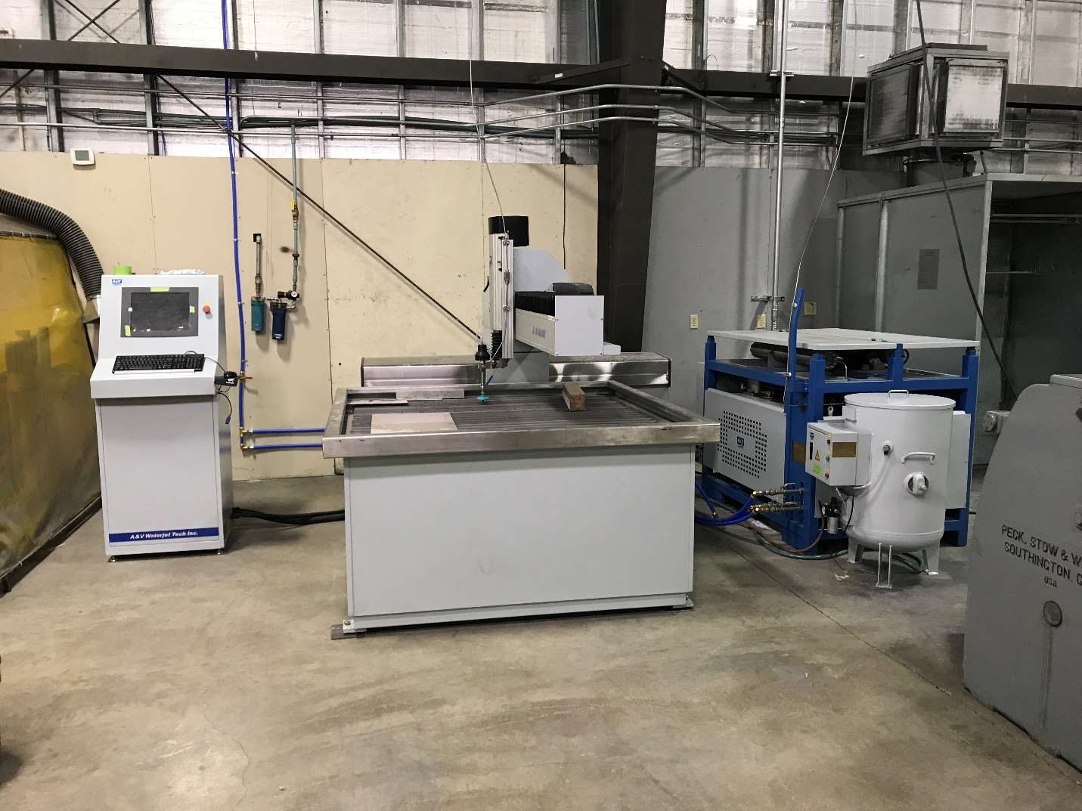

3, Prepare the Electricity, water/air supplies, drain and steel leveling plates;

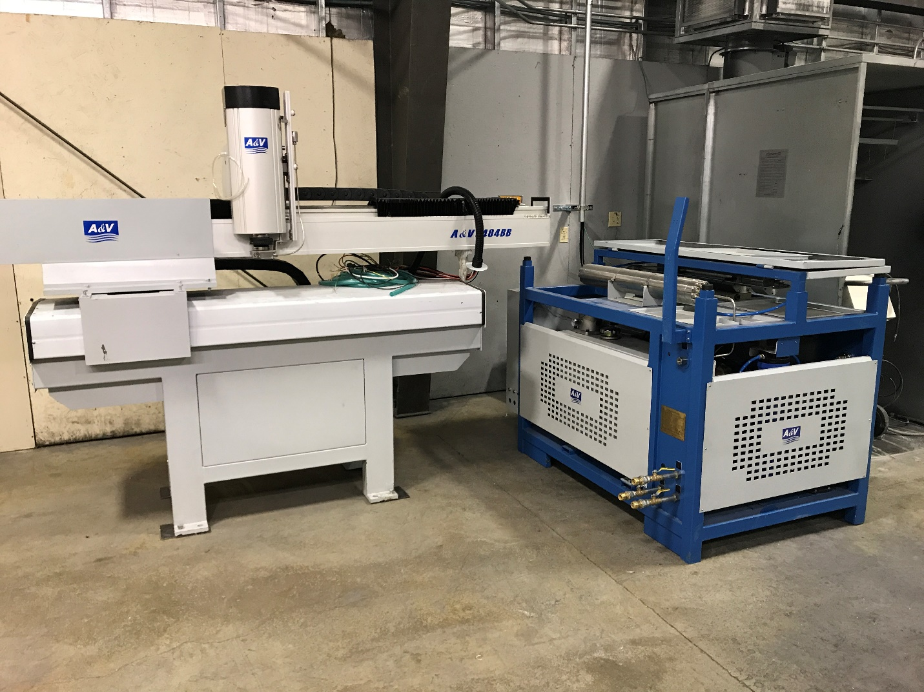

Cooling water inlet

Put Steel Plates under the feet, for later leveling.

Two air supplies, on behind the arm (85Psi), the other one is on the garnet hopper (30Psi)

Cutting water inlet

Drain Water

(Cooling and cutting)

Power supply

4, More specific pictures:

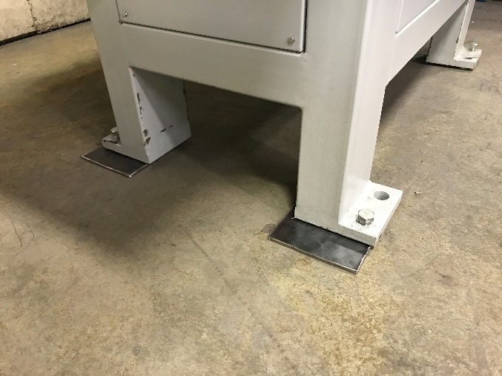 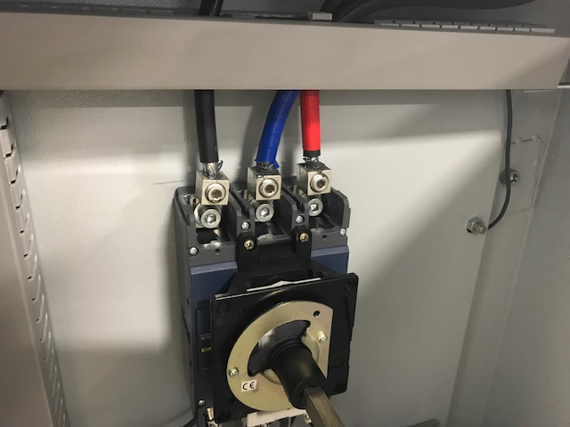

Steel plates (3/8 or 1/4)

Power supply

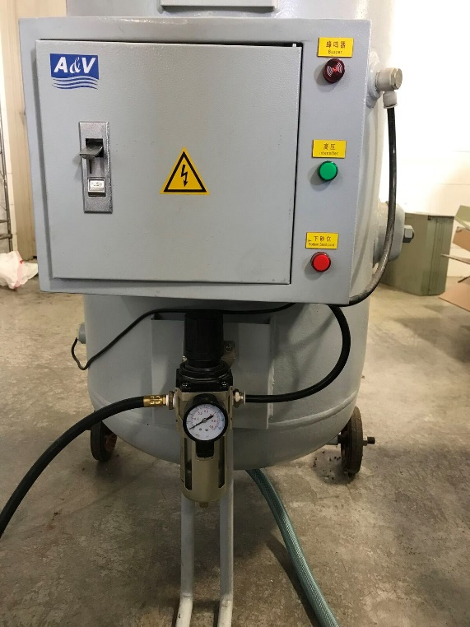 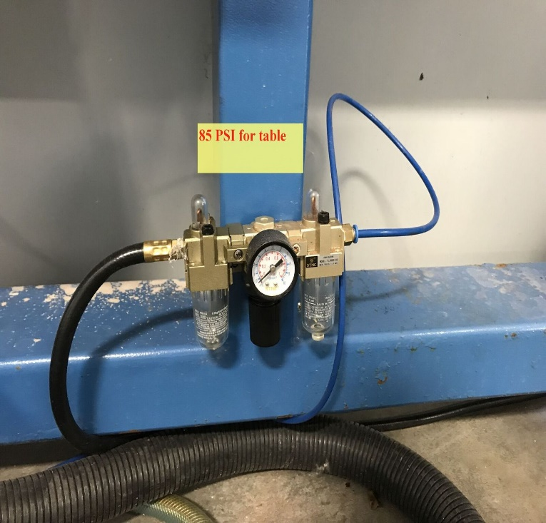

Air inlet to garnet hopper

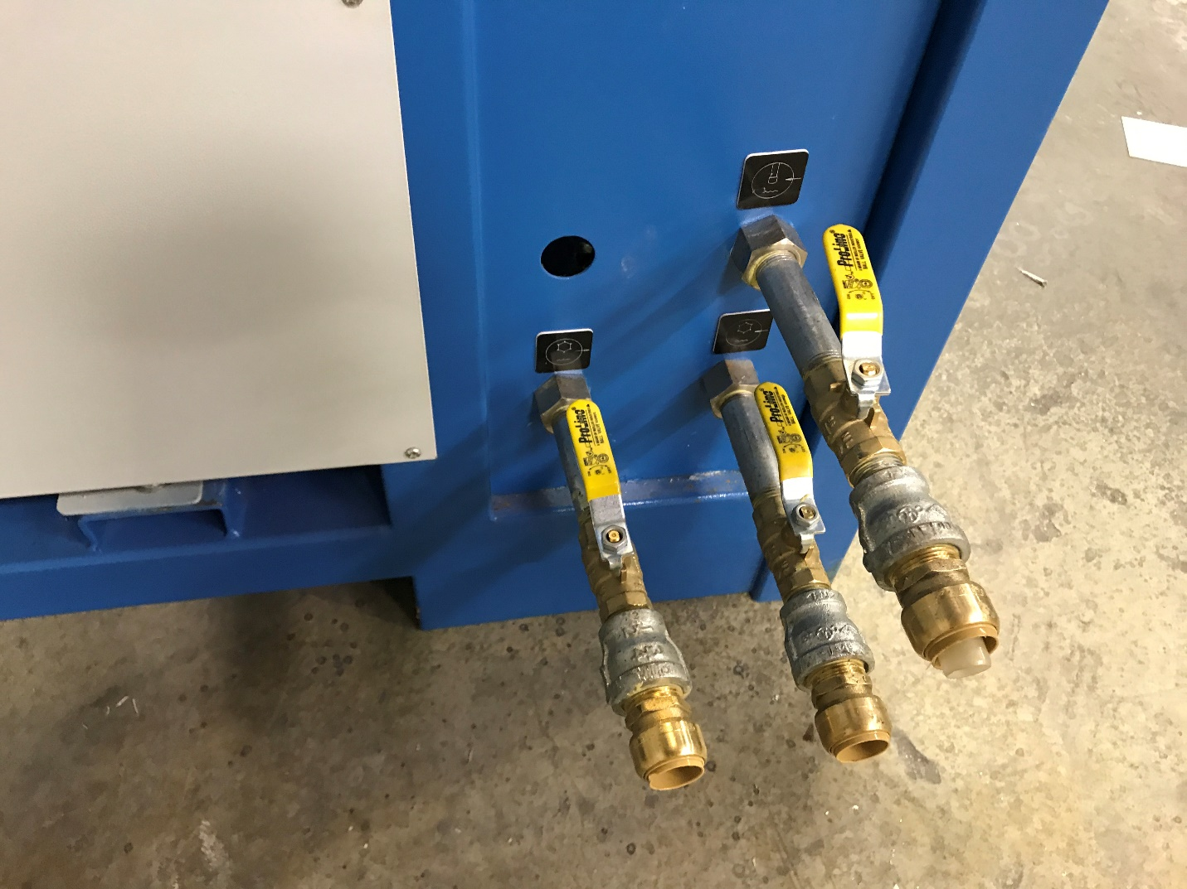

Water lines

(No cooling water required if have oil chiller)

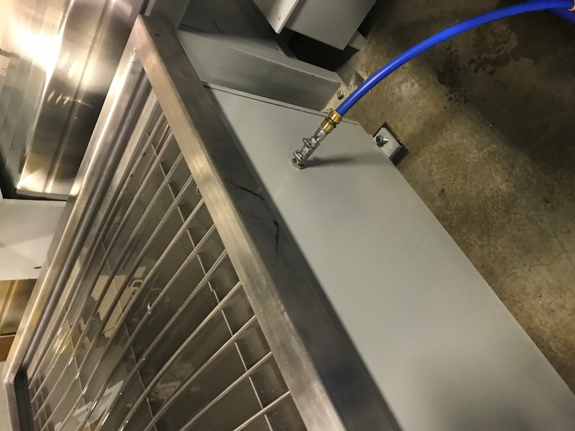

Overflow drain on the water tank

5, Level the arm, and archer on the ground (need technician’s confirmation before this step);

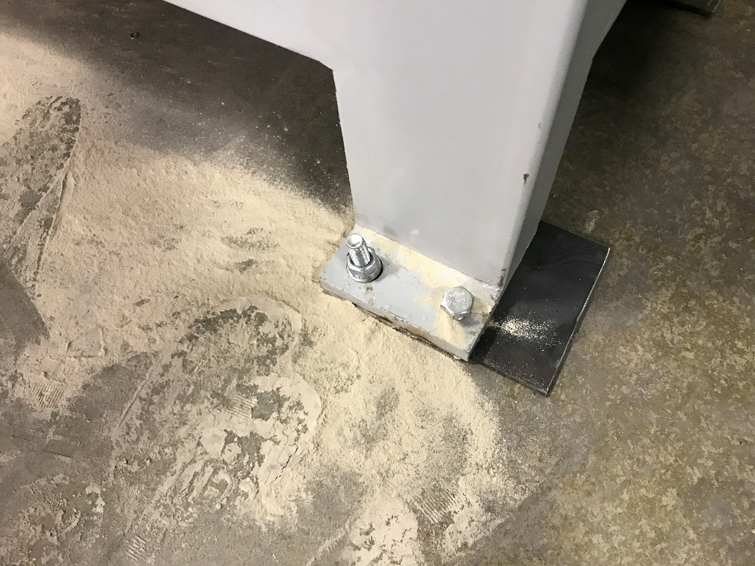

6, spin the fly-arm, bolt it with locating pins:

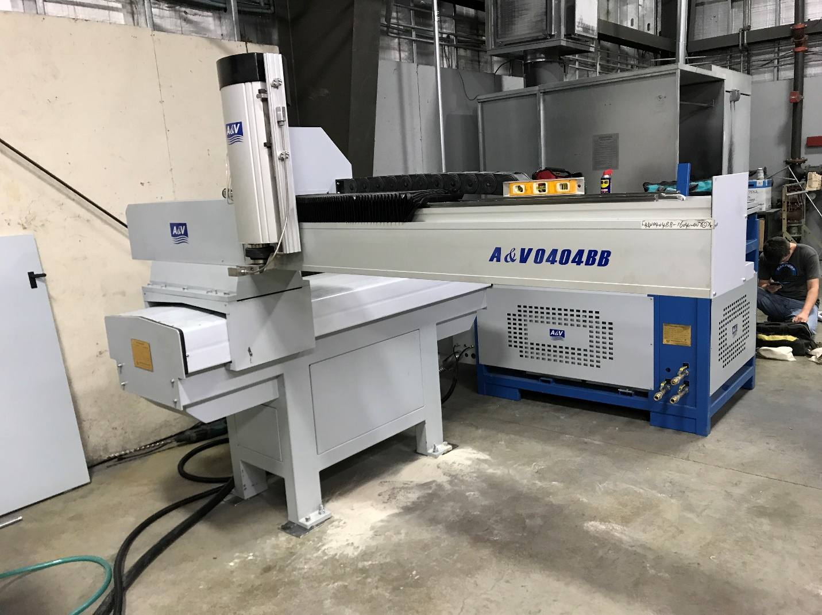

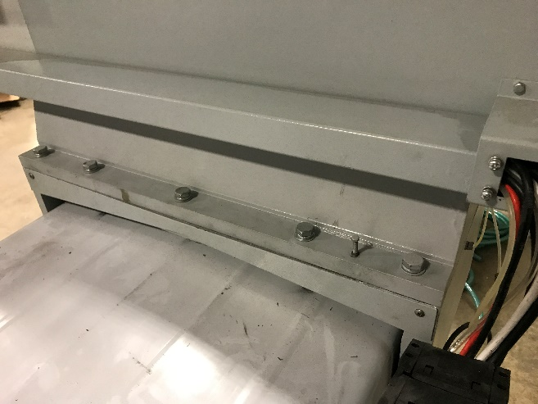 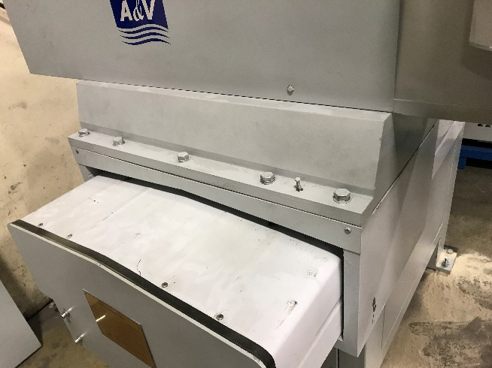

Locating pins

7, Fill up the hydraulic oil tank, with #46 hydraulic oil:

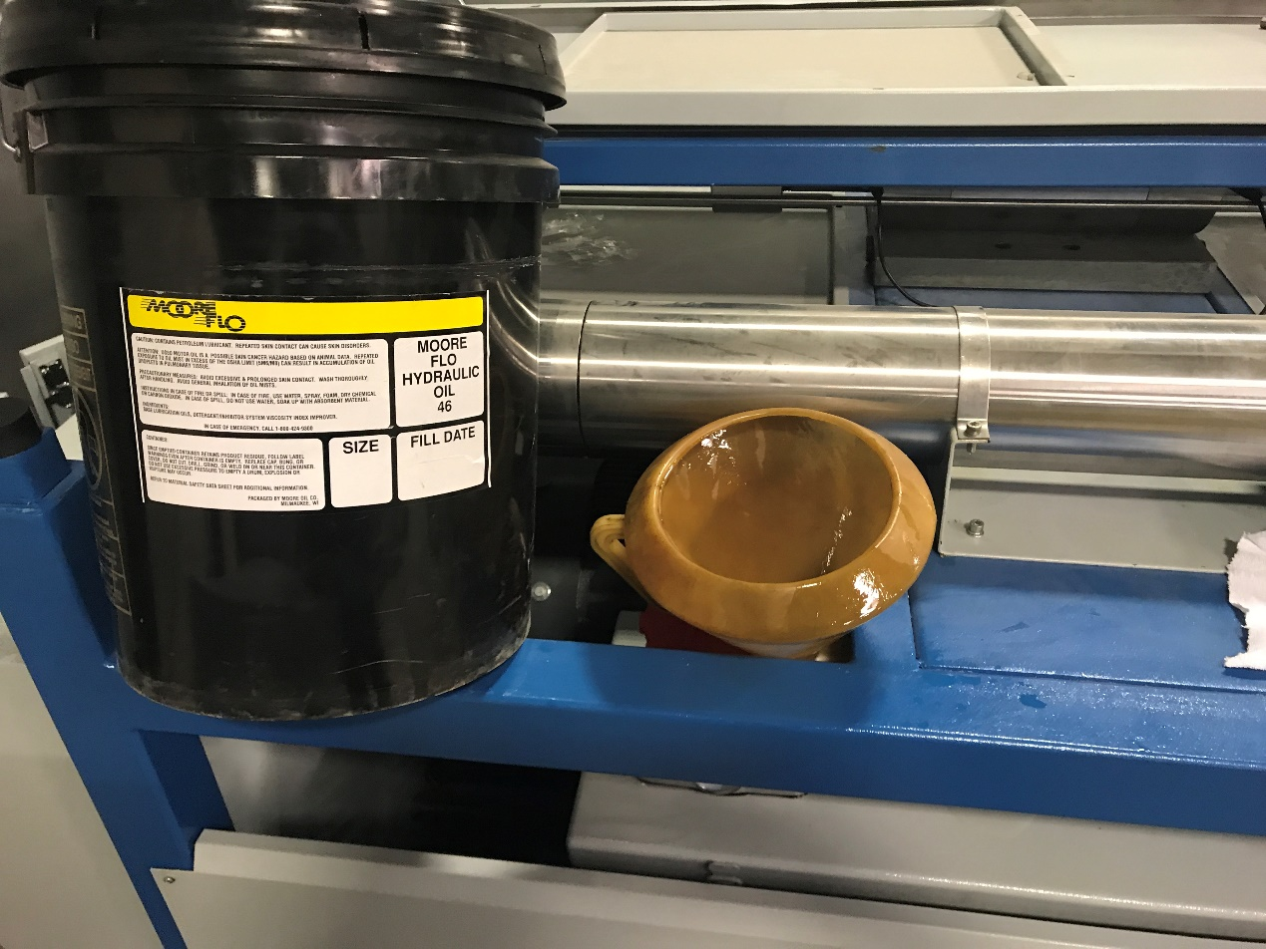

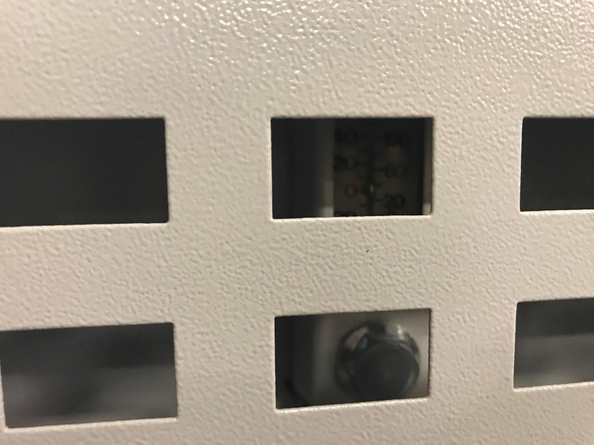

Make sure the oil level above “0”, and be aware don’t over fill the tank.