How to adjust 4-axis cutting head
- Description:
4-axis is used to compensate the cutting angle showing in below picture:
1 to 3 degree
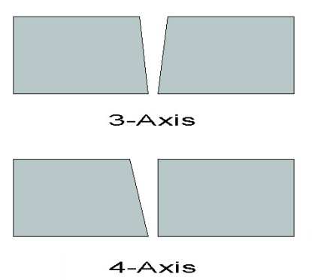
A-axis is angle axis. (0-45degrees)
B-axis is rotation axis. (0-360degrees)

- Adjust 4-axis cutting head:
Step 1: Align the cutting head. Make sure it is straight up and down.
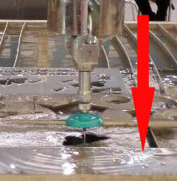
Step 2: Return C-axis to “Original Point”:
Click “F3 JOG” “F5 Tool Jog” “F1 Tool Return”. (Now C-axis will automatically rotate back to 90 degrees.)
Click “MDI”. Input “C0”(C-axis Zero), and click run.

Step 3: Adjust 4-axis to 20 degrees:
- Put a plate below the cutting head. Mark the current point of the cutting head on the plate (point “a”).

- In the software, click “F5 Set Parameter” “ F7 4-Axis Parameter”
Change “Maximum tilt (degrees)” to “20”
Change “Height from rotation centerline to the workpiece” to “193”
- Go to “MDI”. Input “A20” and click run. Then the cutting head will move X-axis to a new position to compensate. Mark the new point of the cutting head on the plate (Point “b”).
- Manually adjust the cutting head to “Point a” and tighten the cutting head.
- Then you may found the cutting head is a little bit off from X-axis side.In the software, Click “F3 JOG” “F5 Tool Jog”. Then Click “+C” or “-C” to turn the cutting head to point at “Point a”, both on X-axis side and Y-axis side.
- In the software, Click “F1 Set Current Point”. Change “C coordinate” to Zero.
- If you need to adjust A-axis to 2 degrees or any other degrees you need, do again “2”, “3”, “4” steps above.
- Now you can start to cut with 4-axis. If you want to change back to cut with 3-axis, just simply adjust the cutting head back to “Point b”, and close 4-axis Control in Parameter. You don’t need to change any other settings.

