中英文翻译对照
Chinese- English term translations
- Intensifier
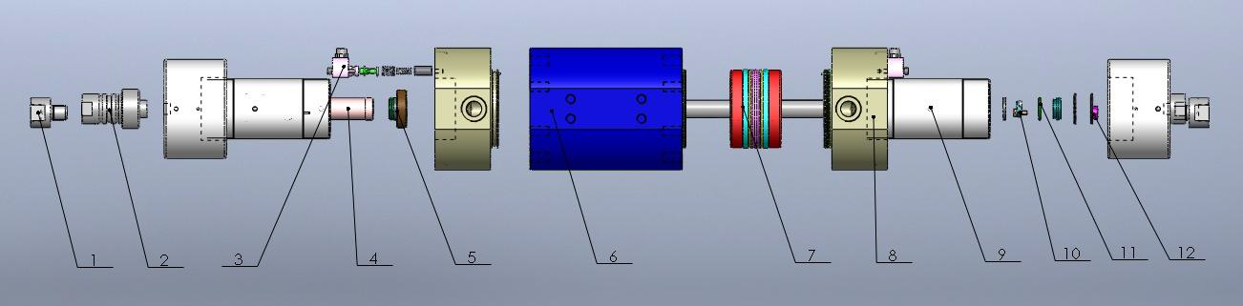
编号 | 中文名  Chinese | 英文名（旧译）  English (old version) | 英文名（新译）  English (new version) | 产品编号  Series number
1 | 单向阀高 | Outlet Check Valve | Check Valve Outlet Body
2 | 塞头 | Chock Plug | Check Valve Main Body
3 | 电器传感器 | Magnetic Sensor Switch | Proximity Switch
4 | 活塞杆导向套 | Backup Sleeve | Backup Sleeve
5 | 高压环组合 | Seal Plunger+ Seal Hoop+ O-ring | High Pressure Rings Package (HP Seal+ Seal Hoop+ UHP O- ring) | 110-20078-0101
6 | 油缸体 | Low Pressure Cylinder | Low Pressure Cylinder
7 | 组合密封圈 | Obturating Rings Assembly | High Load Piston Seals | 17-900017-02232
8 | 端盖 | End Bell | End Bell
9 | 高压缸 | High Pressure Cylinder Assembly | High Pressure Cylinder Assembly | G12039
10 | 高压导环 | Back Up Ring 1 | Back Up Ring 1
11 | O 型圈 | O- ring | O- ring
12 | 高压环 | Back Up Ring 2 | Back Up Ring 2

