A&V Waterjet Centralized Lubrication System User’s Manual

The centralized lubrication system is like shown in the picture below. The dimensions are also attached.

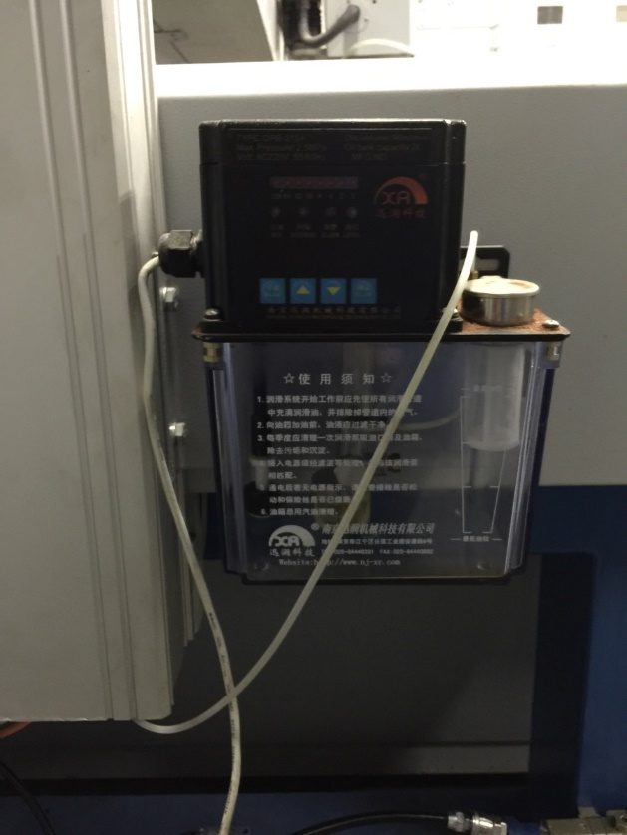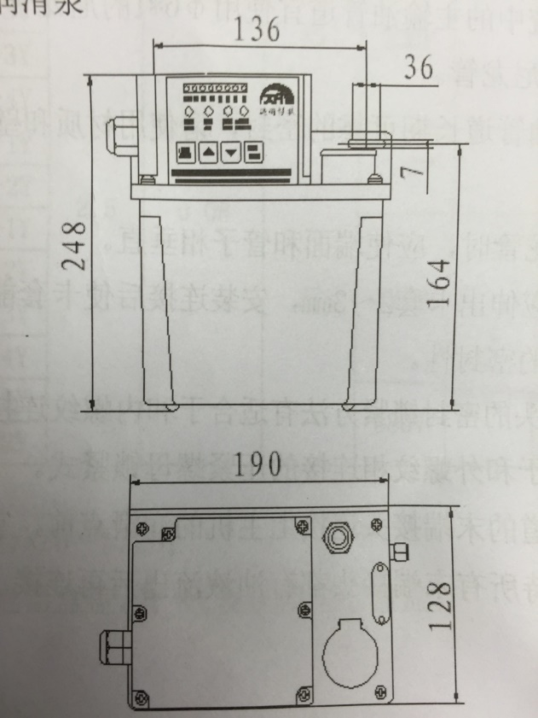

- Power Cord Connection

Separately connect the red, blue and yellow wire with the live wire, neutral wire and the electrode wire (PE) with the bullet-type joints. Below indicates the right connection.
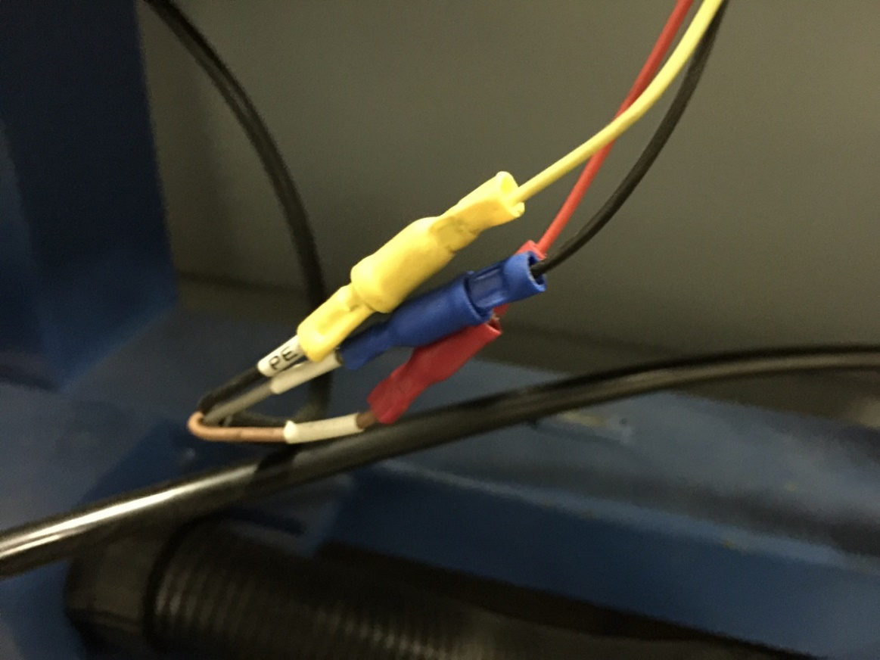
- Control Panel
The control panel is like shown below.
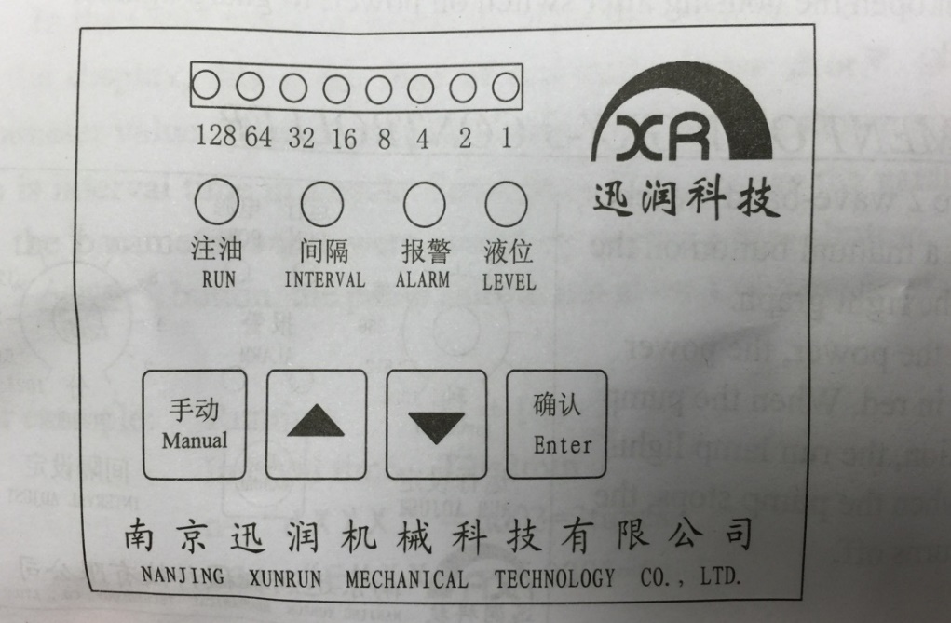

- Adjustment of parameters
- Enter the status of adjustment
Press the ‘Enter’ button and or at the same time, the luminotron will flash.

Whether the controller is in the adjustment or working status of the interval time, the ‘interval’ light will be red and solid.
Whether the controller is in the adjustment or working status of the run time, the ‘run’ light will be green and solid.

- Sequence of Adjustment

- Interval time
Once entering the adjustment status for the first time, interval time will be shown by the luminotron while the ‘run’ light flashes. The adjustment range is 1~255 minutes. Press or to change the value.
Press ‘Enter’ to start adjusting the run time.

Examples

128 64 32 16 8 4 2 1

Interval time = 1+4+16 = 21 min

128 64 32 16 8 4 2 1

Interval time = 1+2+16+32+64 = 115 min

- Run Time
After entering the adjustment status for run time, the ‘run’ light will flash and the interval time will be shown by the luminotron. The adjustment range is 1~255 seconds. Press or to change the value.

Then press ‘Enter’ again, the system will keep all the new parameters and the controller will start to run.

Examples
128 64 32 16 8 4 2 1

Run time = 1+2+4+8 = 15 sec
128 64 32 16 8 4 2 1

Run time = 2+16+32+128 = 178 sec

- Attention
- The system will switch to run status if no button is pressed within 45 seconds under adjustment status.
- In alarm status (no matter with or without pressure), when the lubricant drops below the minimum level, the ‘Level’ light will flash and buzzer sounds.
- The cover of the controller must be safe grounding.
- Do not open the cover of the controller when it is working in case of electrical shock.

- FAQ About the Centralized Lubrication System

Problem | Possible Causes | Solutions
No lights lit up after turning the power on | - The fuse is blown out  - The transformer burned out | - Replace a new fuse  - Replace a new transformer
Only the lights are lit up but nothing works | Parameter setting mistakes on the control panel | Turn off the power and restart the system
All lights and settings are correct while the system is not lubricating | Capacitance is blown out so the motor does not run. | Replace a new capacitance
The lubricant drops below the minimum level but no alarm | The lubricant level switch is broken down | Replace a new lubricant switch

