A&V Waterjet Ballscrews Cleaning Procedure

- For Y1 and Y2 axes (or Y axis for 6*3 machine) and X axis, unscrew the axis cover(s) from the cutting table like shown in the picture.

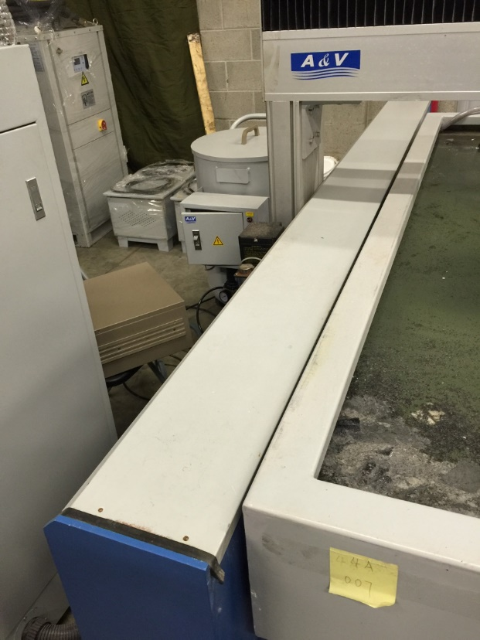

- Lift the axis cover and the inside will be like this:
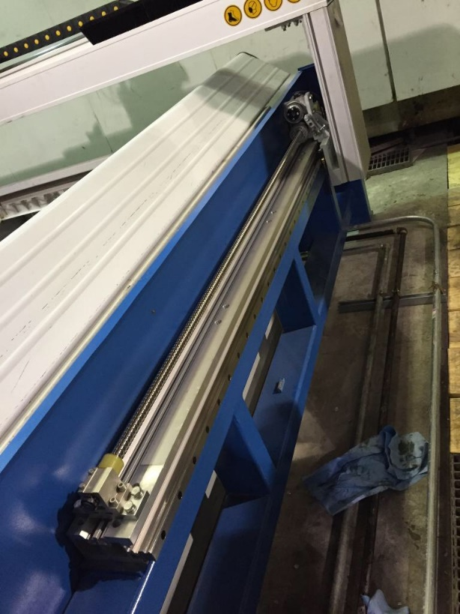

- Carefully clean the ballscrews with clean cloth and wash oil every 3 months. Make sure there is no dusts left in the ballscrews so the axis can move smoothly.

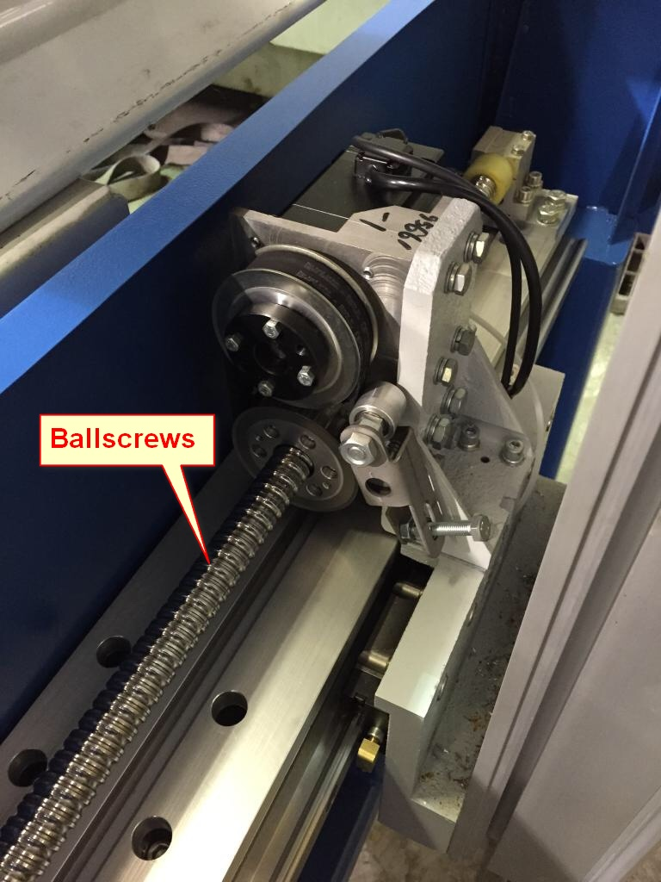

- Put the cover back and the machine will be ready to use.

