A&V Waterjet Water Purification System User’s Manual

The water purification system is shown in the picture below.

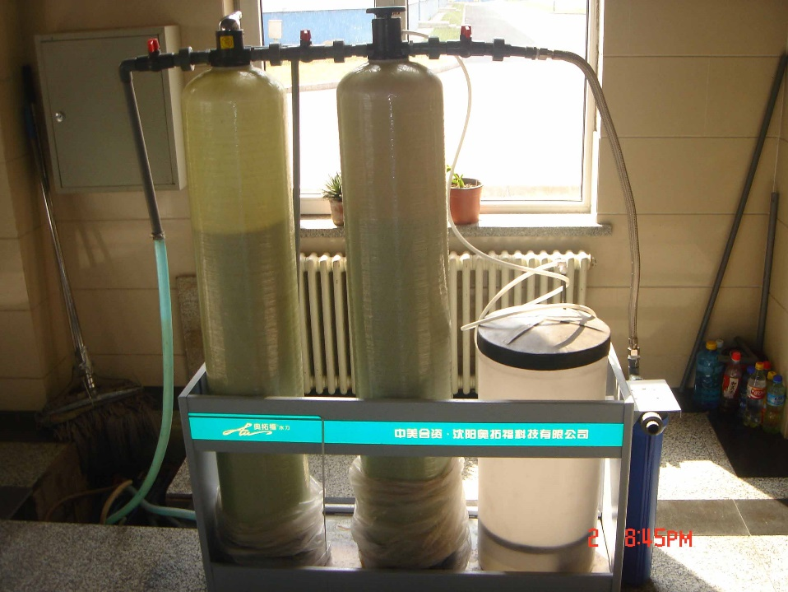

- Installation
- The structure of the system is like shown below

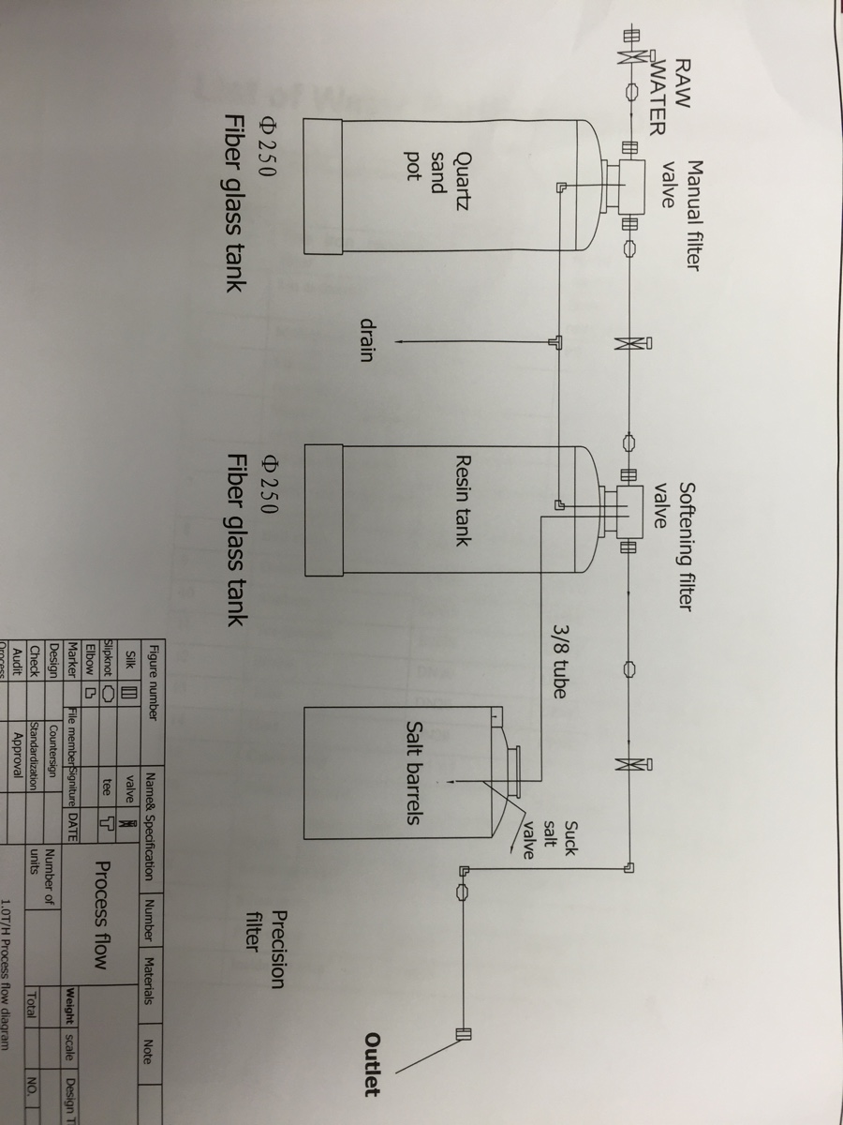
- Installation steps
- Unpack the whole package of the system.
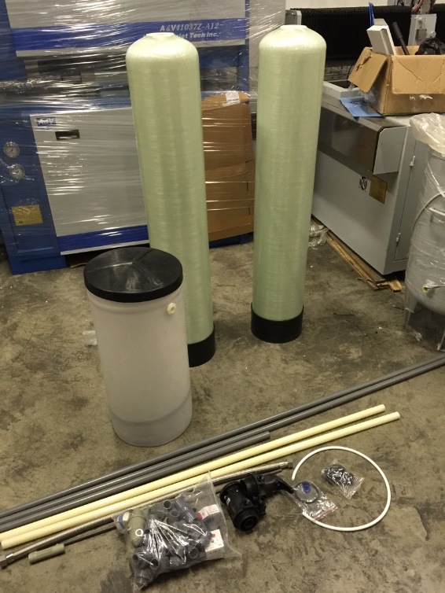
- Install the manual filter valve and softening filter valve separately.
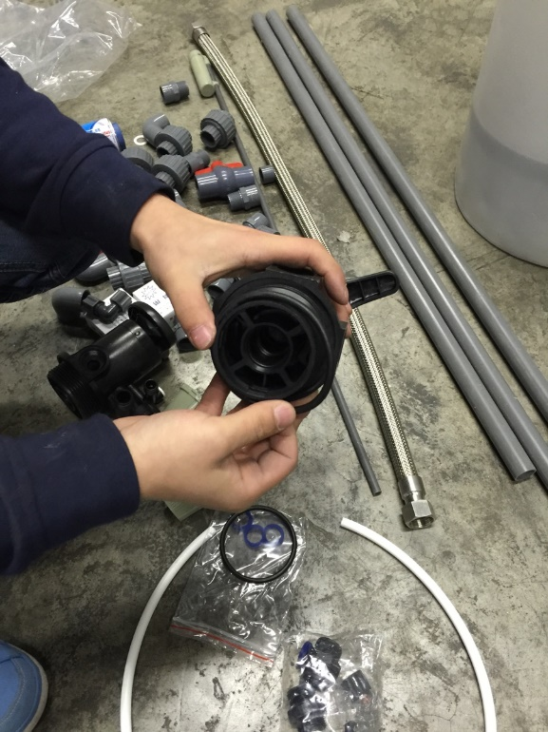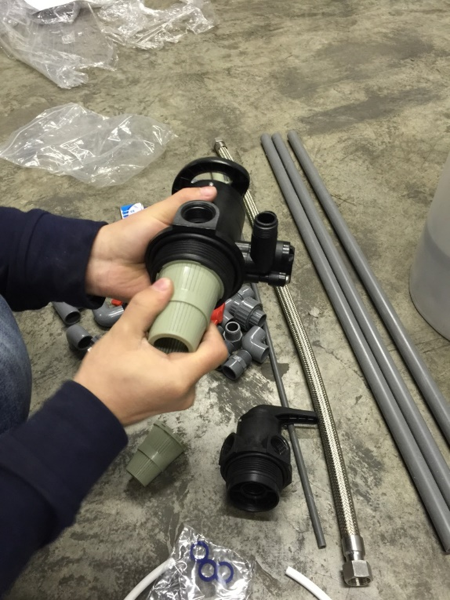

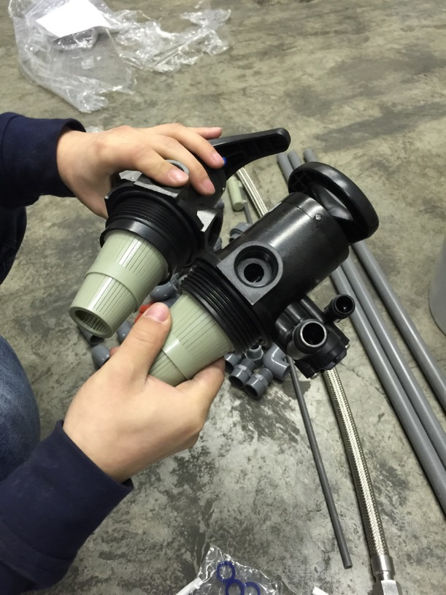

- Connect the manual filter valve to one end of a central tube. The other end should be connected to a bottom strainer like shown in the picture below.
Also do this for the softening filter valve.
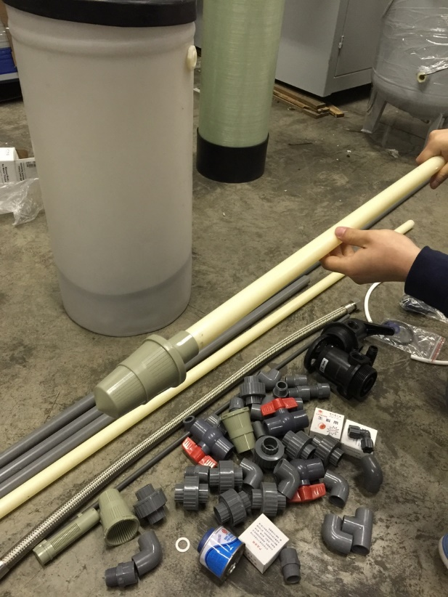
- Plug the central tube into the quartz sand pot with manual filter valve upward while the one with softening filter valve into the resin tank (both of the quartz sand pot and resin tank are fiber glass tanks).
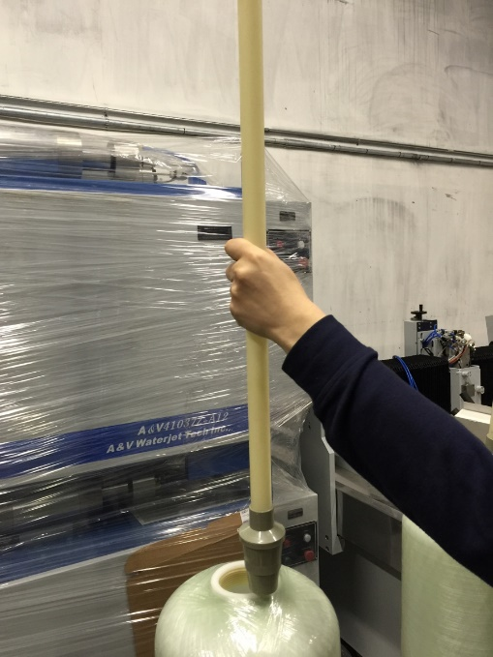
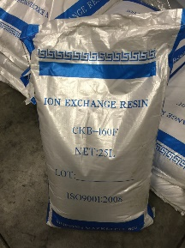
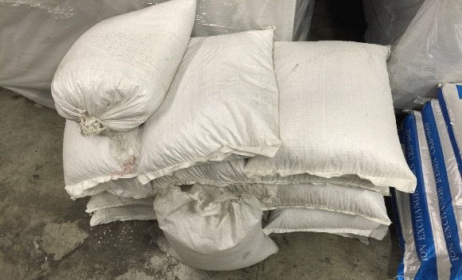
- Pour 3 bags of silica sand into the sand pot and 2 bags of resin into the resin tank. Then screw the valve tightly onto the tanks. You may need to adjust the length of the tubes.
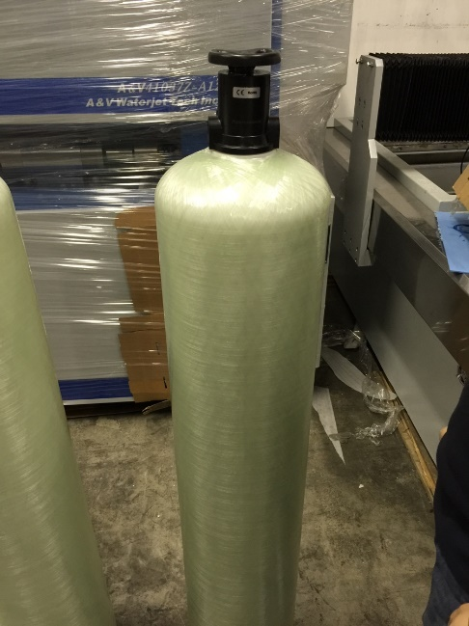

- Cut the gray tube into proper length then connect the 2 tanks with it according to the strcture of the system. Use slipknots and valves in between.

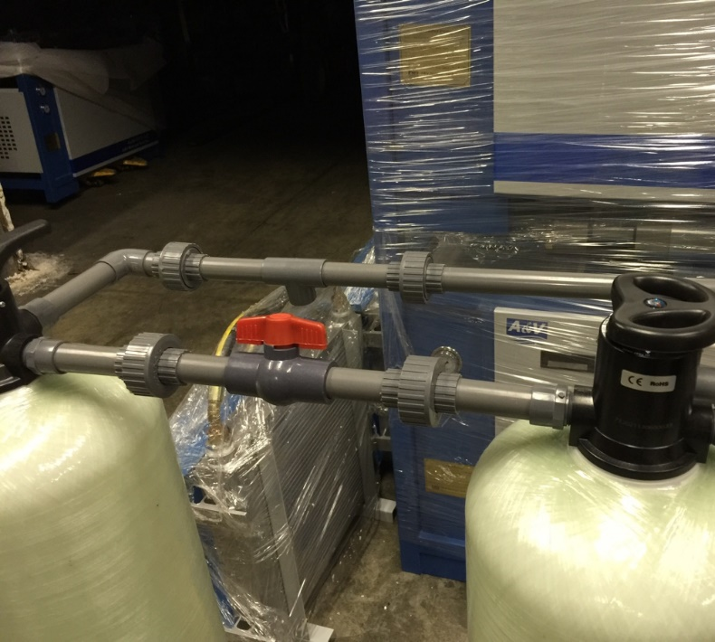
- Connect the resin tank to the salt barrels, following the pictures below and the structure drawing.
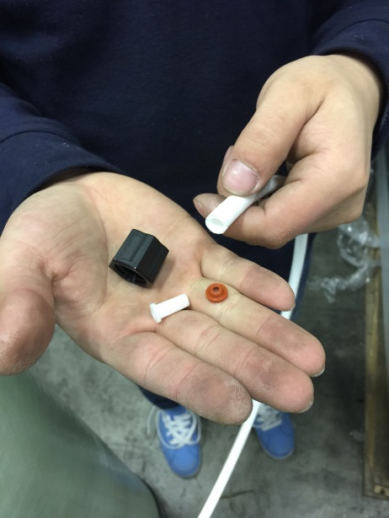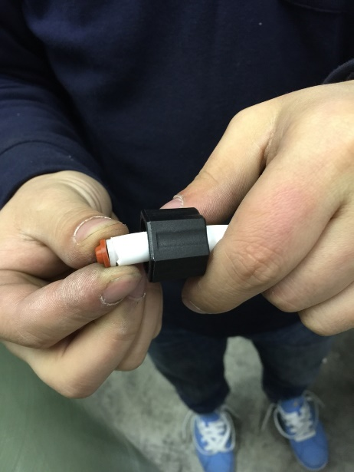
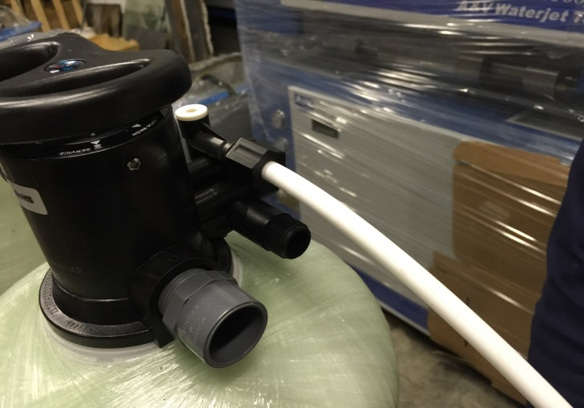
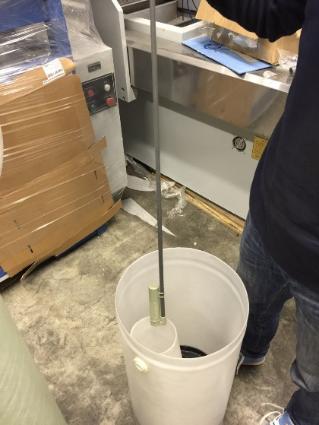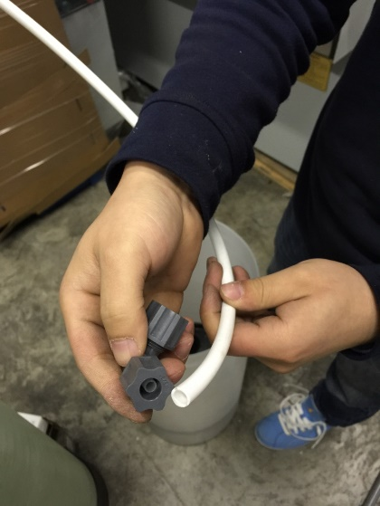
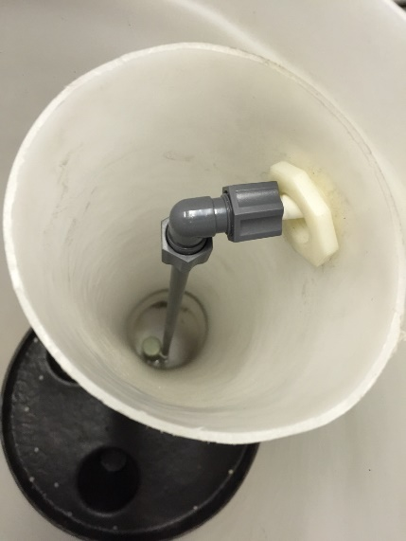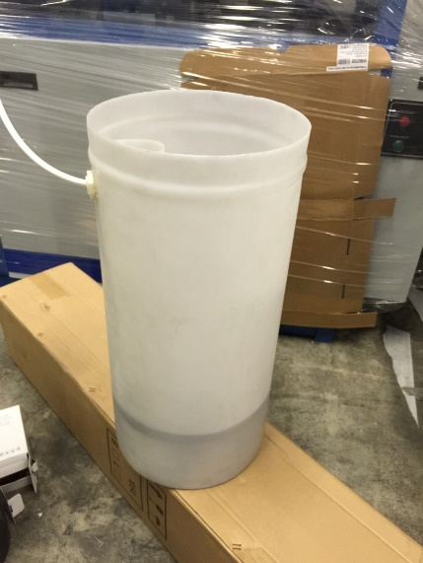
- The final installation picture is shown below. Make sure put it close to drain.
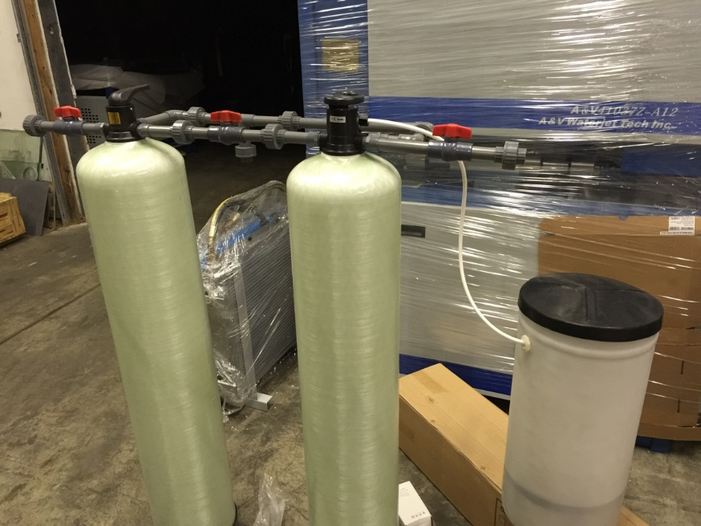
- Maintenance instruction
- For the quartz sand pot. First backwash it for 15 minutes, then rinse it for 15 minutes. After that, transfer to the normal operation position.
- For the resin tank, add salt with water until full. Transfer to backwash position for 15 mins, then rinse for 15 minutes. Clean the water inside and it will be ready to use.
- The maintenance cycle depends on the quality of raw water. If in high quality, the cycle will be once a week, otherwise once 2 days.

For more information, please see the attachment:

