A&V Waterjet Software
Entrance& Outlet lines Instruction

- Click the A&V Waterjet Cutting Software on the desktop.

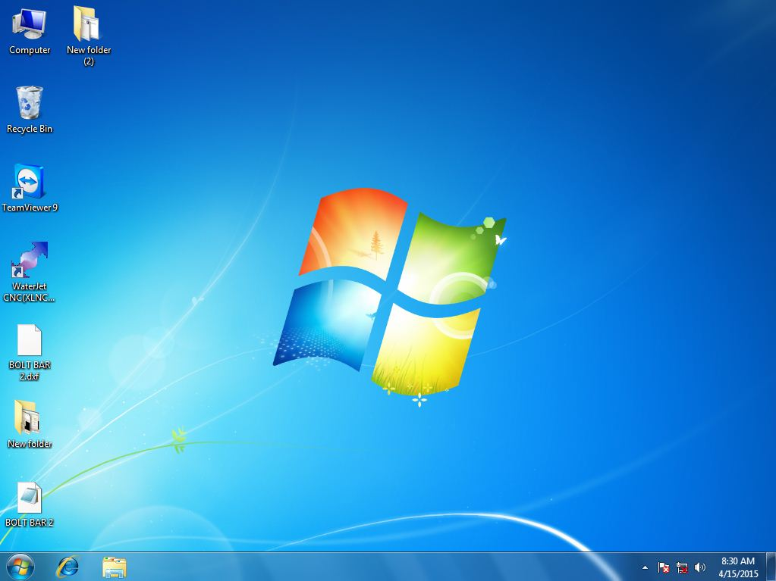

- The mainmenu of the software is like shown below:
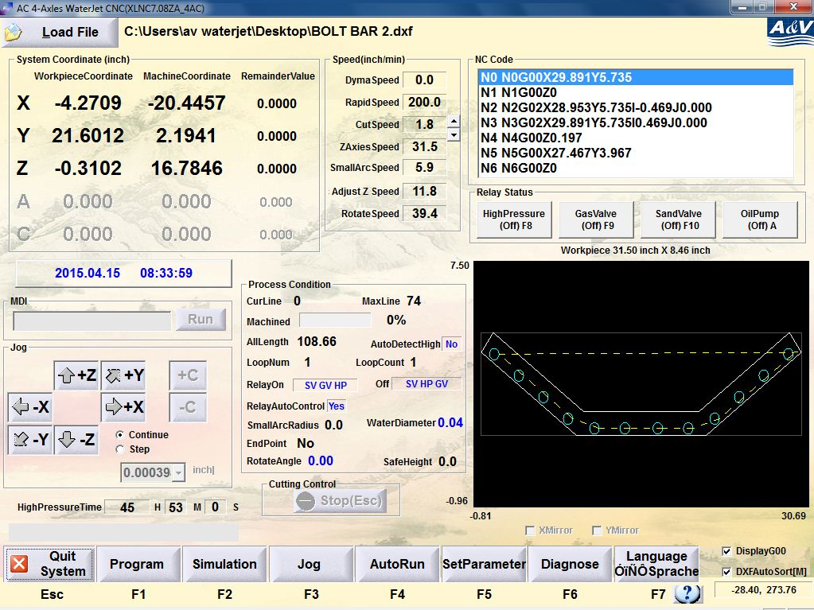

- Click ‘Load file’ to load the DXF file you need to use.
Attention: You cannot create any lead in or lead out lines for a NC file
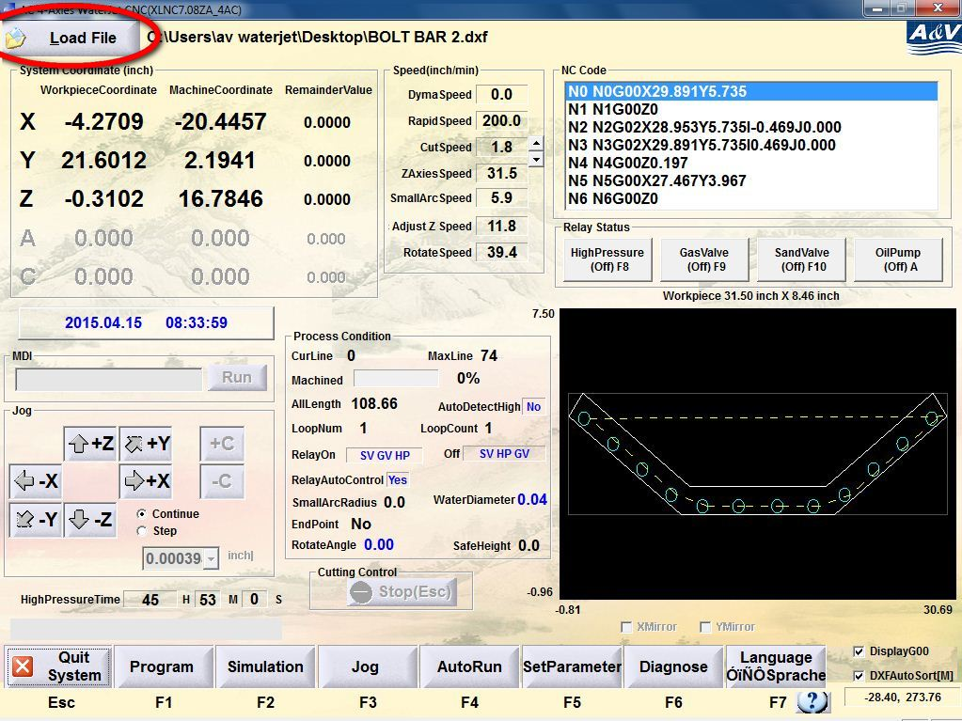

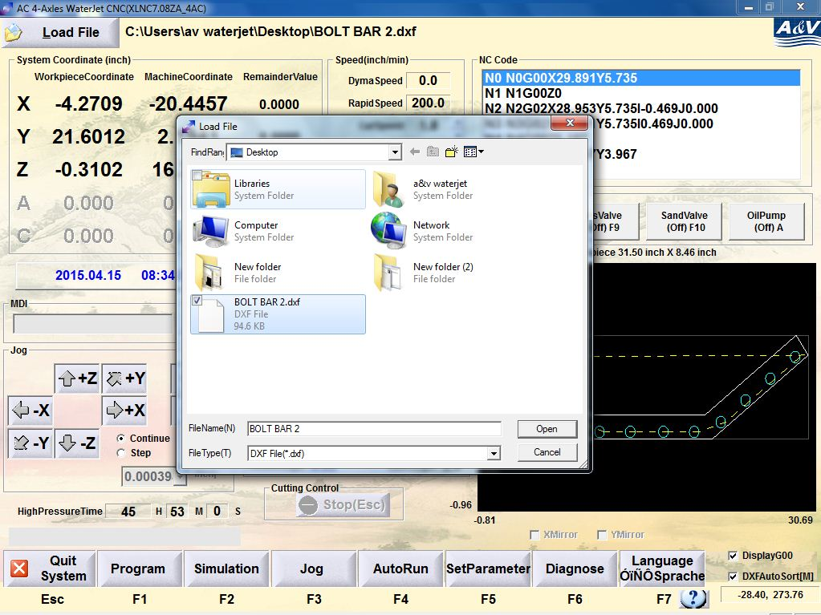

- Make sure the option ‘DXFAutoSort’ circled in red is chosen like this:

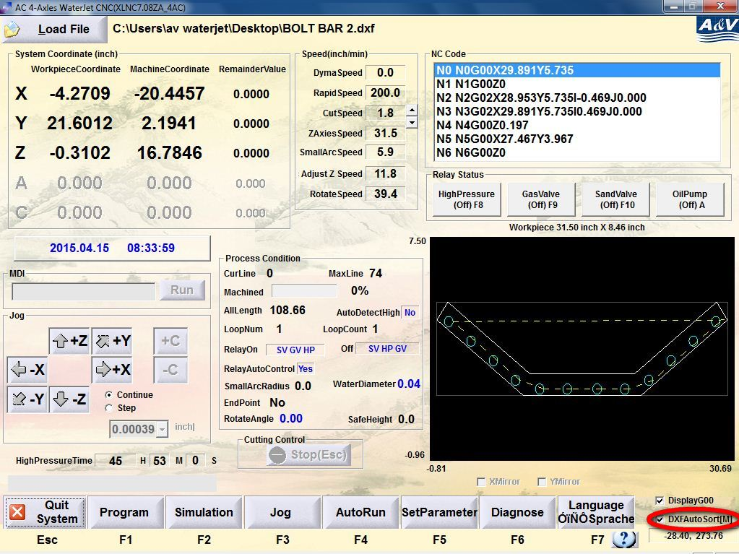

- Click the ‘Simulation’ button or press F2 to enter the simulation menu like shown below:

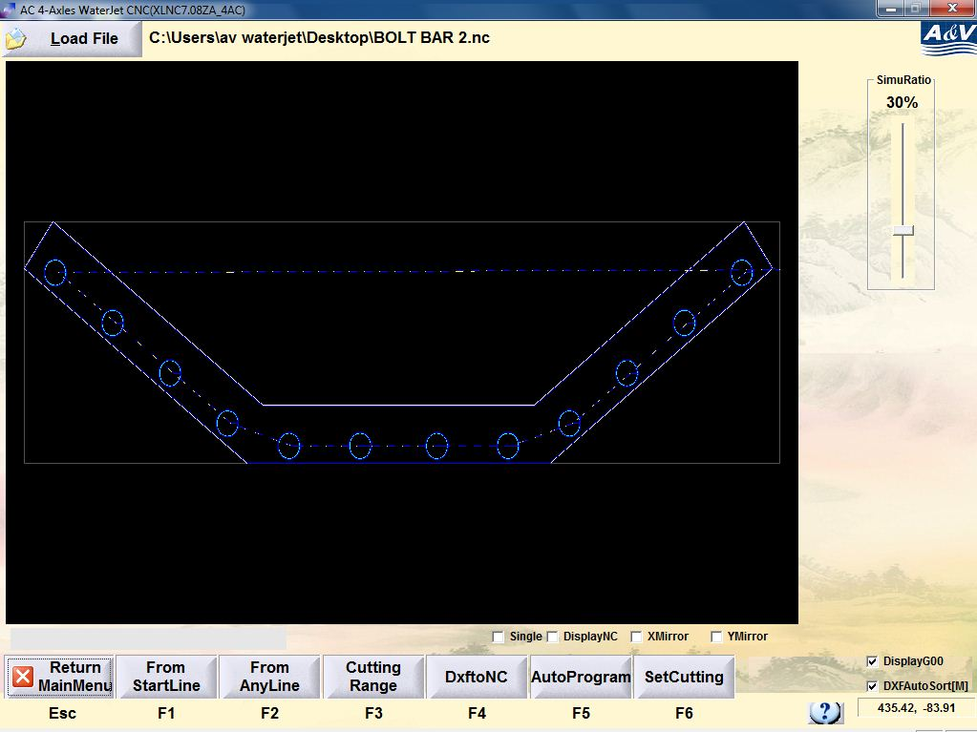

- Click ‘SetCutting’ or press F6 to enter the cut setting tag.

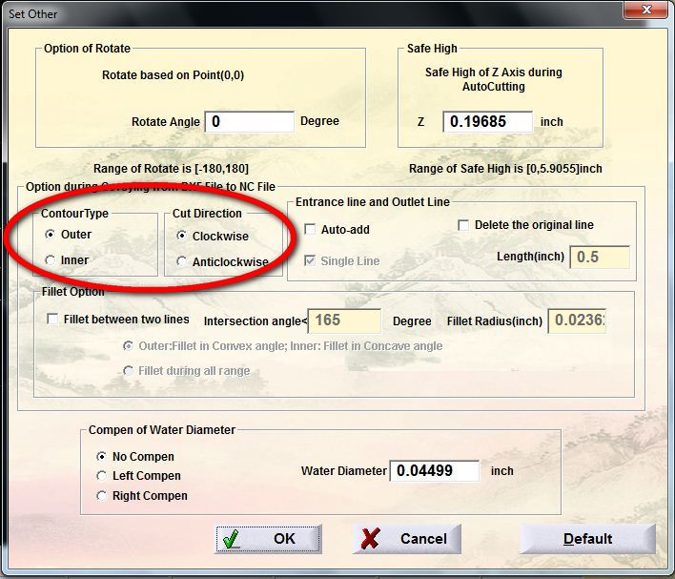

- Make sure to choose ‘Outer’ in the Counter Type and ‘Clockwise’ in the Cut Direction which are circled in the picture above.

- For the ‘Entrance line and Outlet Line’

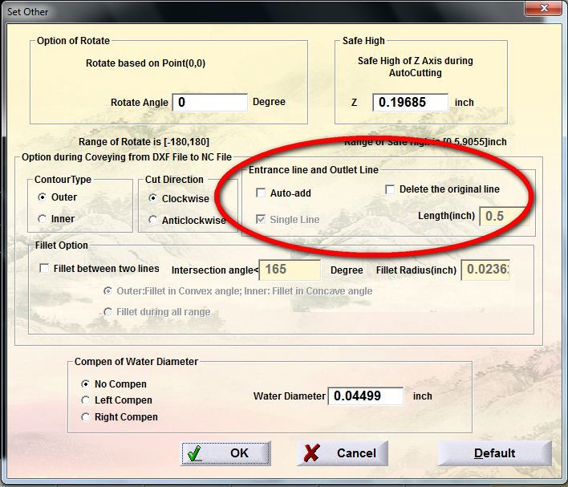
- If there is no entrance or outlet lines in the original file and you want the system to add them automatically, choose ‘Auto-add’. The lines will be added like shown in the picture below.
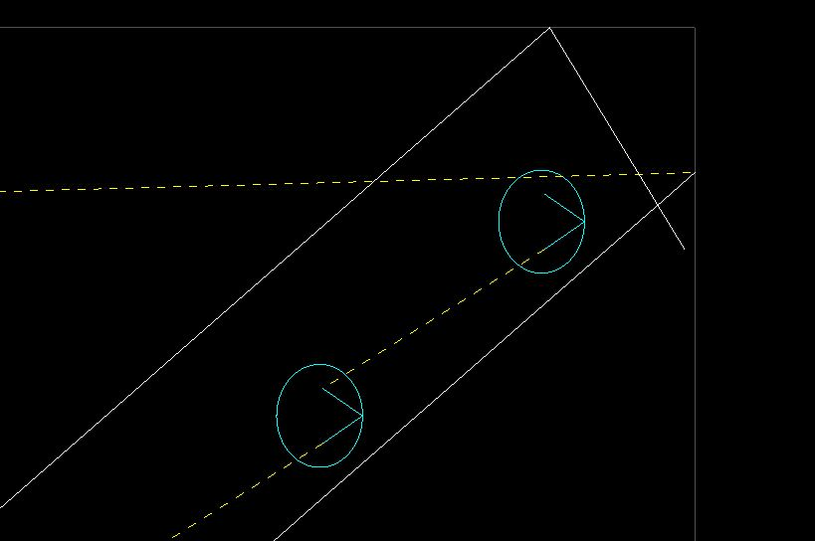
- If you want to merge both the entrance and outlet lines, choose ‘Single Line’.

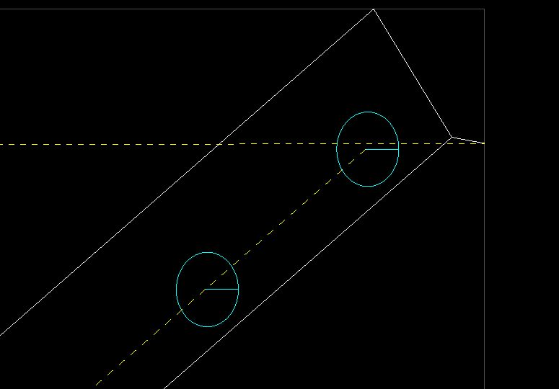

- If you want to delete the entrance and outlet lines in the original file, choose ‘Delete the original line’.

- Also you can adjust the length of entrance and outlet lines by entering value in the ‘Length (inch)’ box.

- Compensation

- Due to the width of the water flow, compensation may be needed. If so, choose the ‘Left Compen’ in the ‘Compen of Water Diameter’ and set the water diameter to proper value.

- Double check the cutting routes after setting the compensation. The dark blue lines shown in the drawing represent the actual border of the part while the green or white ones represent the cutting route of the waterjet. Make sure the waterjet will run through a correct track.

