APW Waterjet Operating Instruction

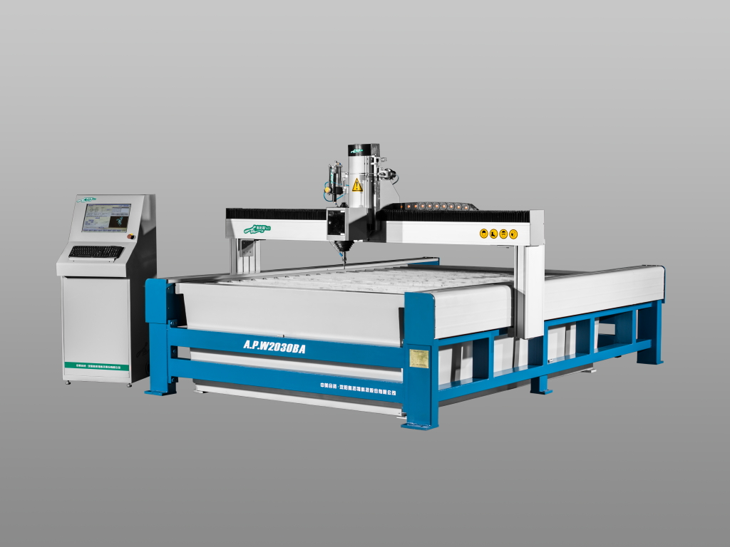

Chapter1 Use AUTO-CAD to model your graphic and save as DXF file 3
1.1 Model your graphic in AutoCAD 3
1.2 Draw Zero Point 3
1.3 Save DXF file. 3
1.4 Select the graphic you want to cut. 5
Chapter 2 Prepare for Cutting 6
2.1 Load the file 6
2.2 Enter Simulation 6
2.3 Start Simulation 7
2.4 Cutting process setting 8
Chapter 3 Home the machine 11
3.1 Position and secure the material 11
3.2 Horizontally position the cutting head 11
3.3 Vertically position the cutting head. 12
3.4 Set Zero Point 12
3.5 Check for fit and interference. 13
3.6 Set End Point 14
3.7 Set Speed 14
3.8 Set holing time 15
Chapter 4 Run the machine 16
4.1 Check 16
4.2 Automatic Cutting 16
4.3 Stop the machine 16
4.4 Continue cutting 16
4.5 Start from any part 16

Chapter1 Use AUTO-CAD to model your graphic and save as DXF file

1.1 Model your graphic in AutoCAD
Model your graphic that you want to cut in AutoCAD. Please note the cutting path should not overlap or cross.

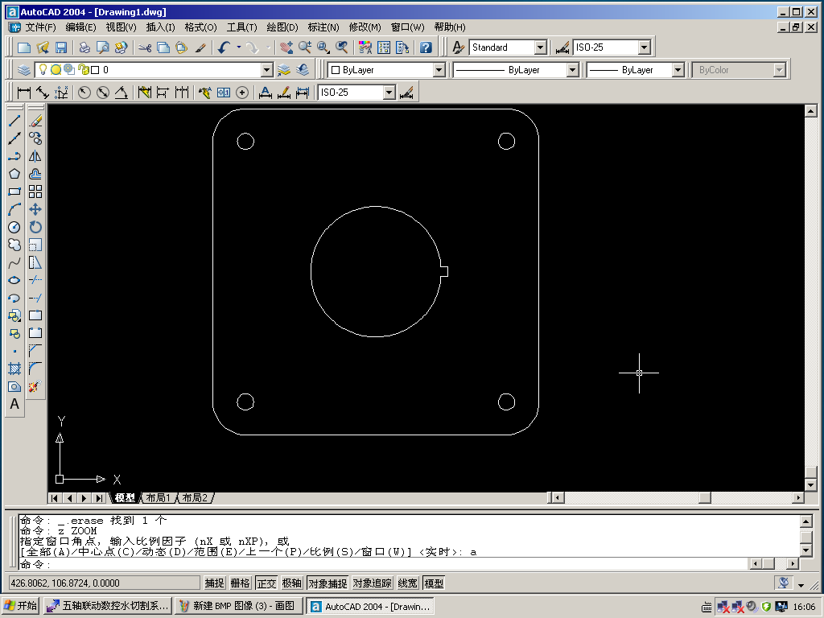
1.1

1.2 Draw Zero Point
Draw a point in the bottom-left corner of the file. It will be considered to be the Zero Point. (X0, Y0).
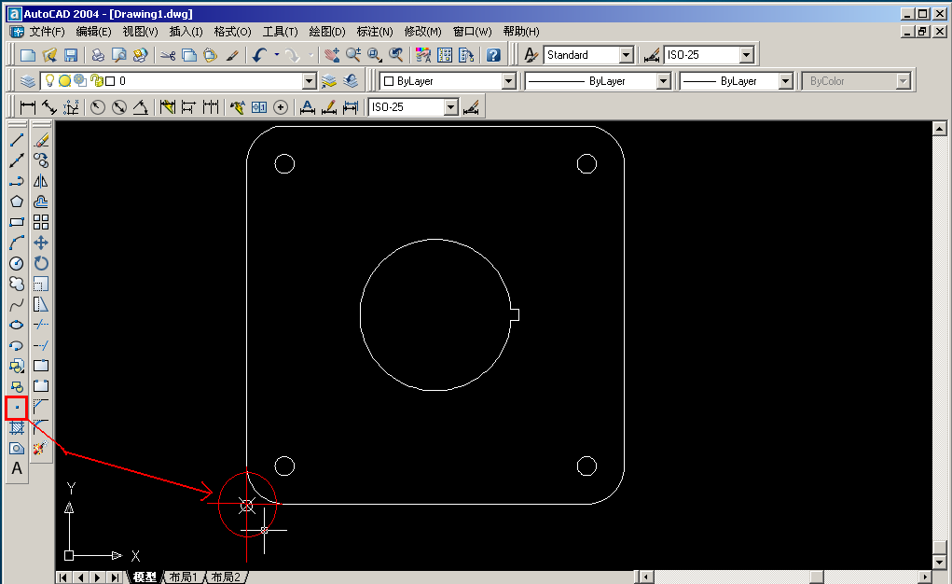
1.2

1.3 Save DXF file.
After drawing the graphic, click the upper-left button 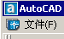 in the software interface, then select “save as”
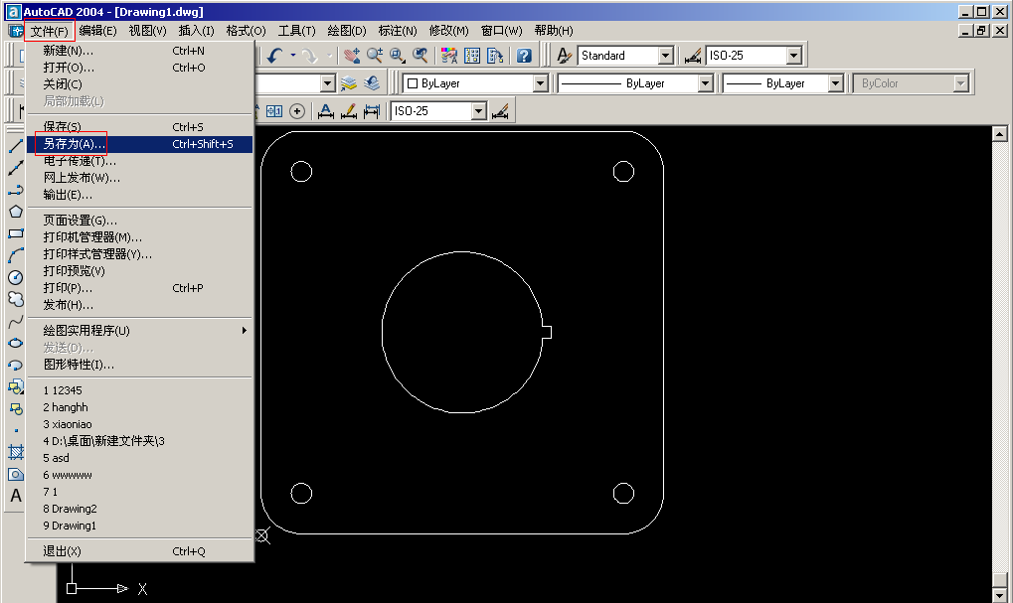
1.3
As it is shown in the picture below:
- Select the destination folder. (picture 1.4)
- Name the file (picture 1.4)
- Set file type to “.dxf”. (picture 1.4)
- Click “tool” on the upper-right corner. (picture 1.4)
- Click “options” (picture 1.5)
- Click “DXF options” (picture 1.5)
- “Select objects” (picture 1.6)
- Click “OK” (picture 1.6)
- Click ”Save” (picture 1.6)

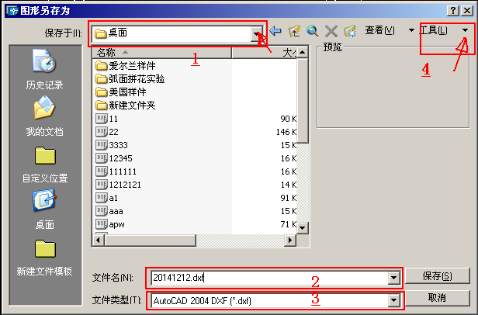
1.4
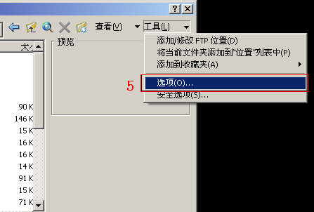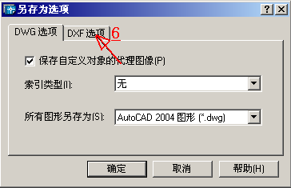
1.5
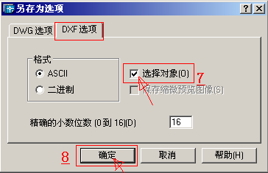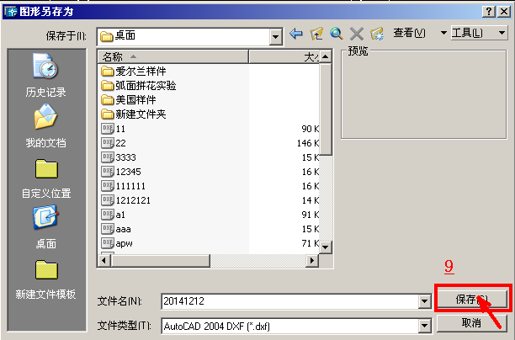
1.6

1.4 Select the graphic you want to cut.
After finishing the operations above, the mouse will become square shape.
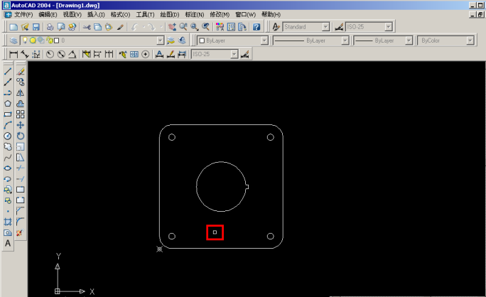
1.7

Select the Zero Point and the graphic. This can be done with multiple clicks and drags. The selected graphic will become dotted line. Then press “Enter” in keyboard to save.

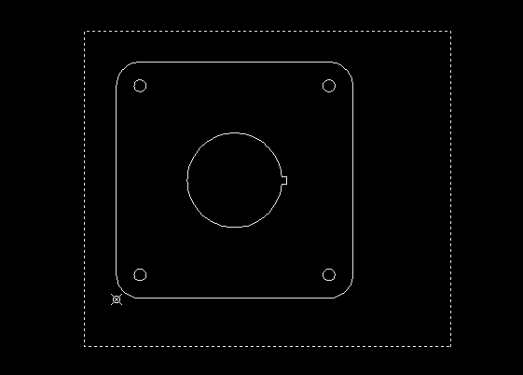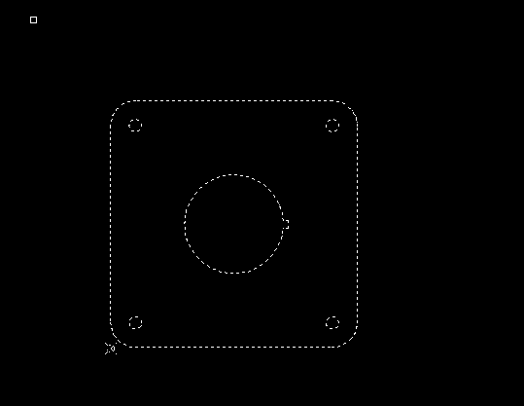
1.8

Chapter 2 Prepare for Cutting

2.1 Load the file
Copy your file to the CNC computer.
Open waterjet cutting software.
Click “Load File” (picture 2.1)
Select and open your DXF file. (Picture 2.1)

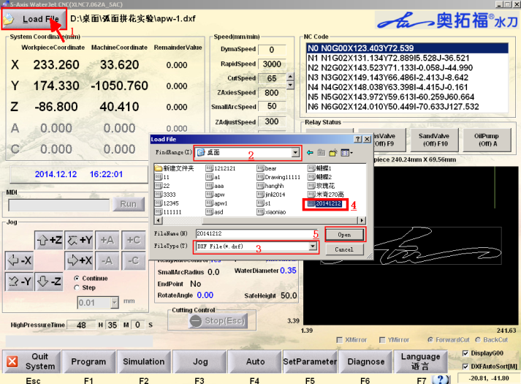
2.1

Then the cutting graphic will be displayed on the software. (Picture 2.2)
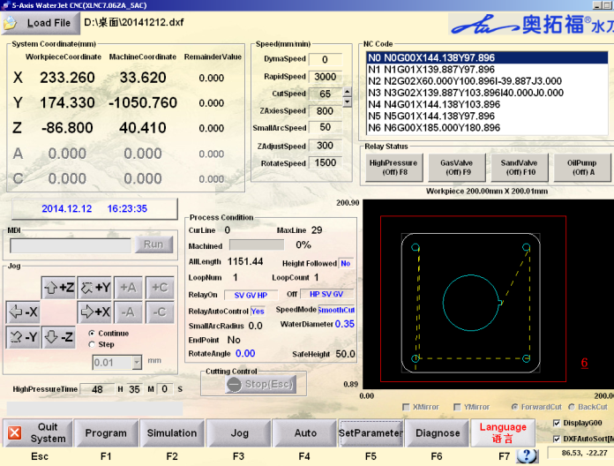
2.2

2.2 Enter Simulation
In the waterjet cutting software, you will see 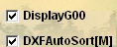 in the bottom-right corner. Make sure both of the options are selected.

Click 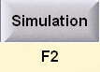 to enter the simulation process menu.
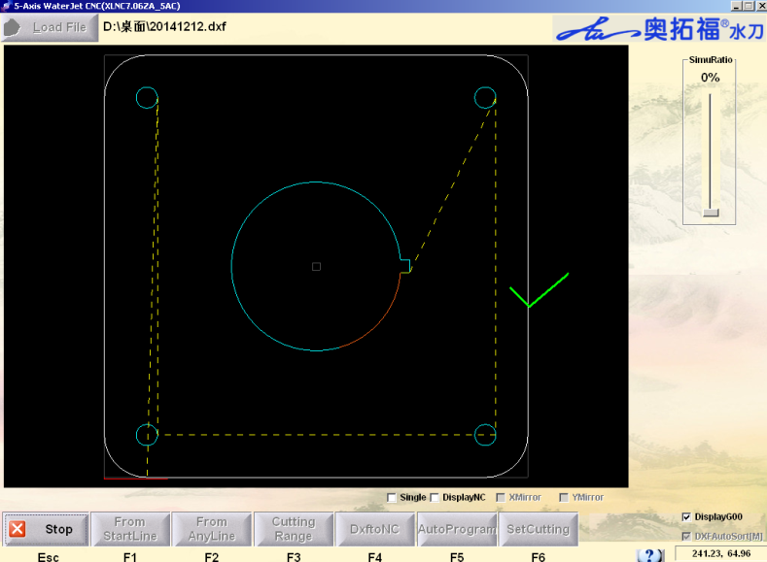
2.3
NOTE: If red lines appear in the file, it means there is open-loop or repeating lines in it. It will affect your cutting. If they are not drawn on purpose, please correct it in CAD and load the file again. (Please refer to Picture 2.4)
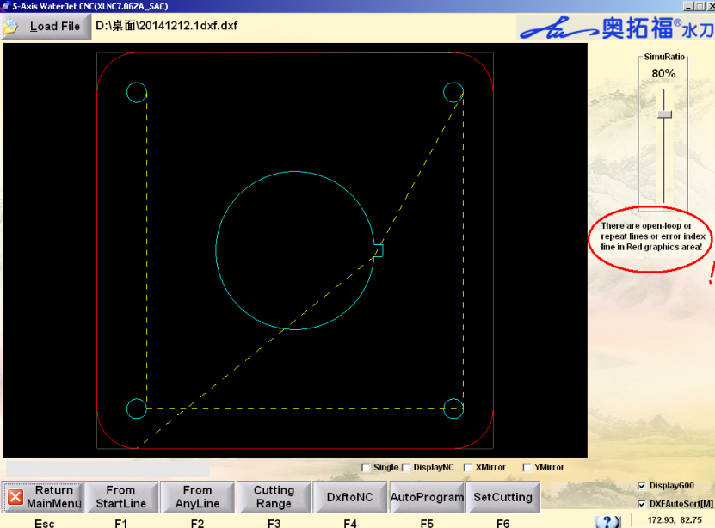
2.4

2.3 Start Simulation
Turn down the simulation ratio to slow down the simulation. 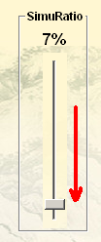
Click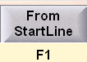, then the software starts to show the cutting path automatically.
The purpose is to check the cutting sequence, and check if the cutting parts are correct. Please make sure that you should always cut inside parts first and cut outside parts last.
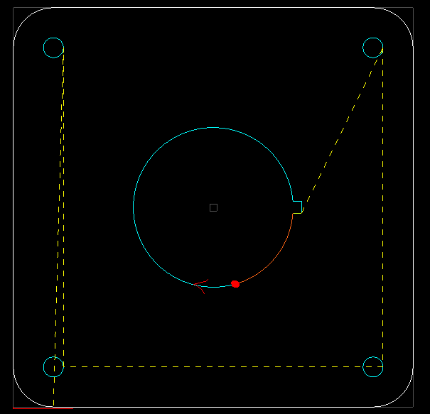
2.5
Tips: You can select before simulation to check the NC code for each move. You will need to keep pressing “enter” in keyboard to simulation.
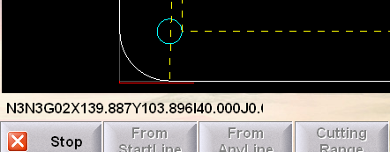
2.6

2.4 Cutting process setting
Click 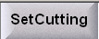 to enter into cutting process setting
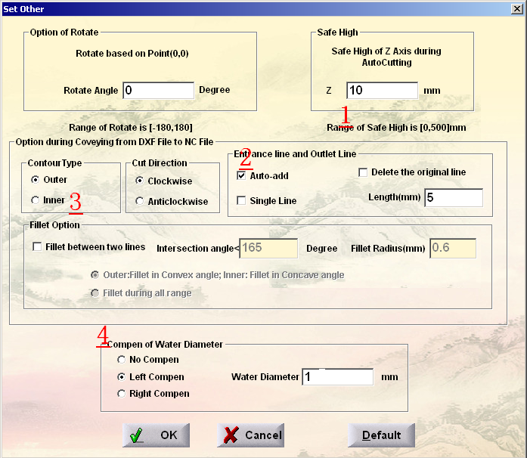
2.7
1. Set Safe Height

Set the safe height, 10 mm is preferred. This will avoid the collision of the nozzle when cutting head is auto positioning.
2. Set Entrance line (lead in) and Outlet line (lead out)

Select. Input the length of Entrance line and Outlet line.
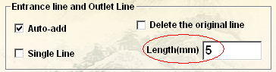
2.8

Picture 2.9 and 2.10 are before and after adding the above two lines.

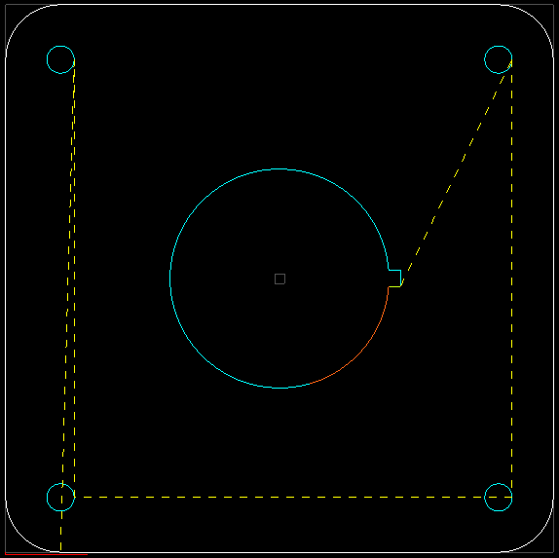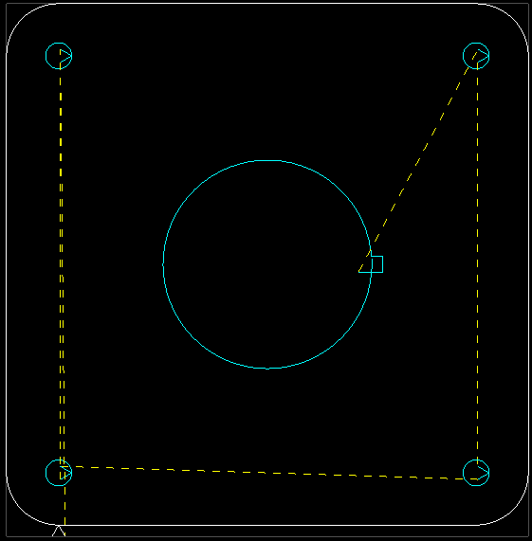
  - 2.10

Tips: The lead in and lead out Length should not be bigger than the radius of the circle.

Why do we need to set Entrance line and outlet line?
Before waterjet can begin cutting along a contour, it first has to pierce the material. As the material is being pierced, when there is not yet a hole all the way through, the jet of waterjet and abrasive hits a dead end, spreading out sideways and spurting back out of the hole. As a result, the initial piercing leaves a hole that is wider than subsequent cuts. Entrance line and Outlet line keep pierces away from the edge of a part, preventing imperfections.

3. Choose the contour type

Please choose “outer” or “inner”. The purpose is to add entrance line and outlet line on the removed parts.

For example: as shown in the Picture 2.2.8, the shadow part will be reserved; the blank part will be removed. Choose to let the entrance line be added in the removed part.
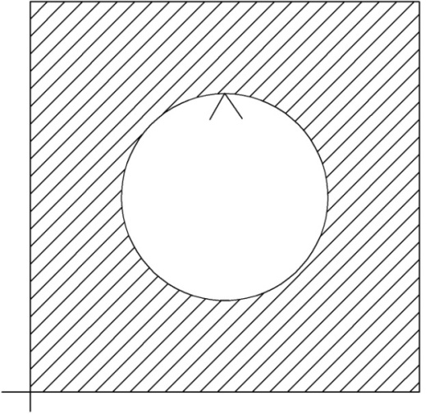
2.11
4. Add Cutting compensation

Please add cutting compensation according to the diameter of the nozzle. Our company nozzle diameter is 1mm, so please input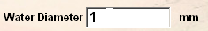.
Then choose or to add the cutting compensation path on the removed part.
As picture 2.2.9: The shadow area is reserved part; red lines are the new cutting path.
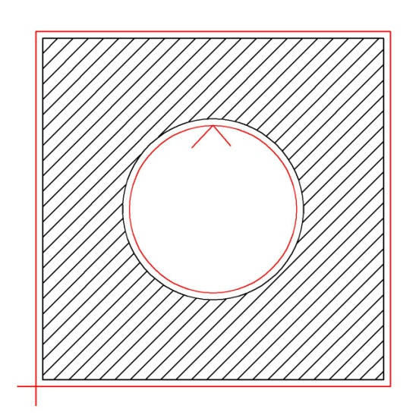
2.12
Why do we need to set cutting compensation?
During cutting process, waterjet will leave a 1-2mm cutting gap on the work piece due to the water jet stream diameter. Therefore the size of the cut-out piece will be smaller than what you drew. You will need to add the compensation for cutting accuracy. With the using of the waterjet, the nozzle will wear out and the water jet stream will get wider and wider. You will also need to change the compensation setting as well.

Chapter 3 Home the machine

3.1 Position and secure the material
Place the material on the cutting table.
Try to orient the material so that its edges are parallel to the sides of the waterjet table.
Secure the material on the cutting table
To keep the material from moving or lifting up into cutting head during cutting, you can clamp the material, or use some heavy objects to press or squeeze the material firmly.

3.2 Horizontally position the cutting head
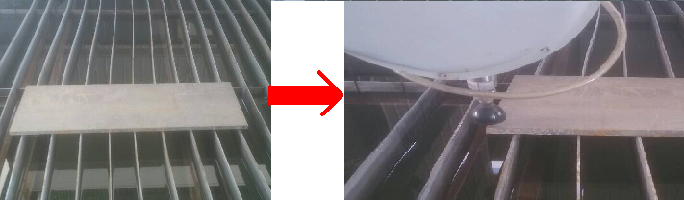
3.1 3.2
Use the arrow keys 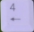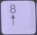 on the keyboard to move the cutting head to the bottom-left of the material. You can also click 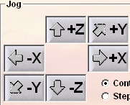 to move the machine. Please watch out and not crash the cutting head.
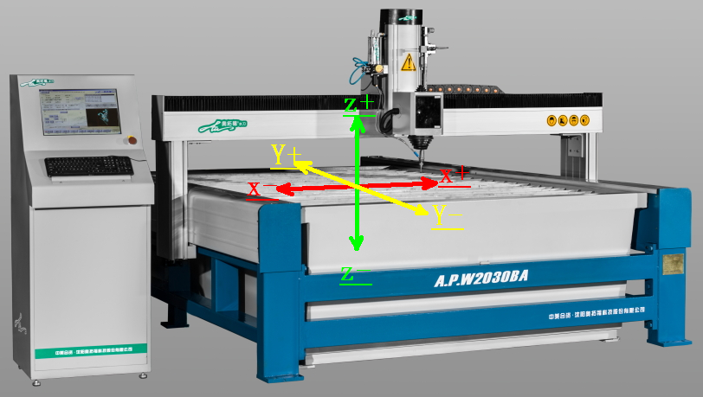
3.3

3.3 Vertically position the cutting head.
Press “Page Down” in keyboard to lower the cutting head to about 3-5mm above the material. Check the alignment of the cutting head with the material.
Tips:
To correctly set the gap, you can find a 3-5mm plate to check.
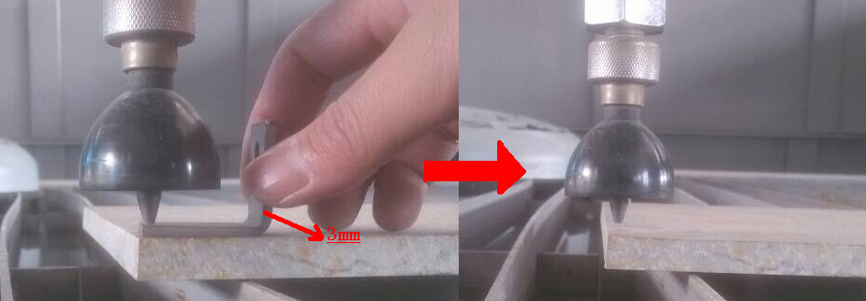
3.4
Note: The G00 moving speed of X, Y, Z axis can be adjusted in 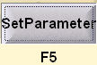 →. We suggest to set X, Y axis moving speed (G00 Max speed) 3000mm/min. Z axis speed 800mm/min.

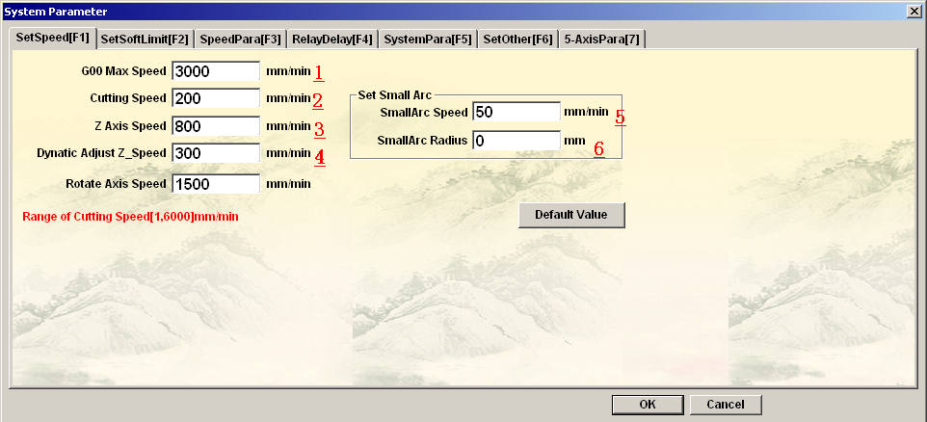
3.5

3.4 Set Zero Point
After positioning the cutting head, please click 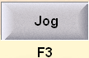 → 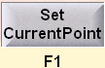 .
Change X, Y, Z axis to Zero Point
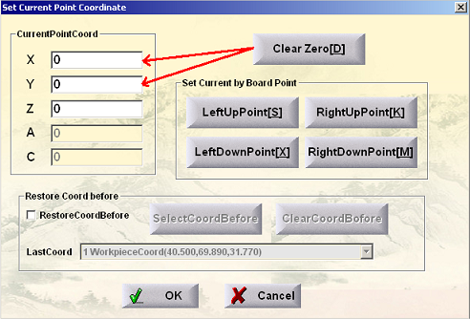
3.6
Now you have successfully set the cutting head to the machine Zero Point, which coincide to the point you drew in AutoCAD. You will also see a red point in the computer screen, which indicating the cutting head position.

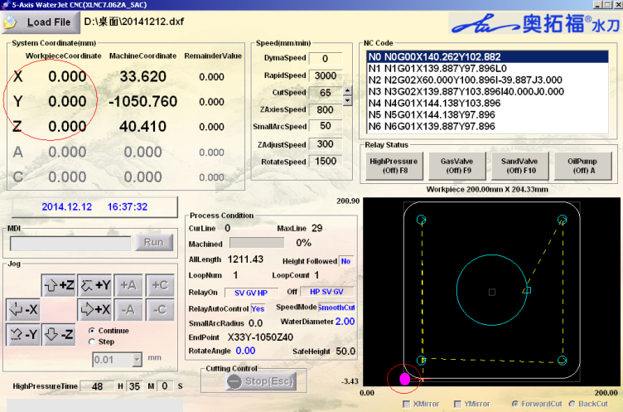
3.7

3.5 Check for fit and interference.
Press in keyboard to move the cutting head along the edge of your graphic. Make sure the cutting head does not run into any clamps or go off the edge of the material. Be ready to stop in case a collision is about to occur.
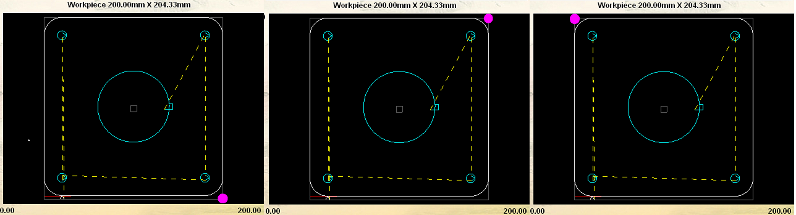
3.8

3.6 Set End Point
End point is where the cutting head will automatically move to, after the cutting process finishes. Move the cutting head to the end point you want.

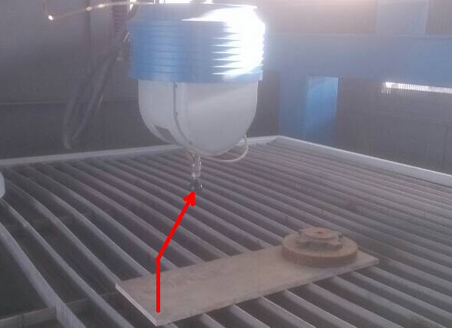
3.9
Click →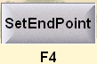→ 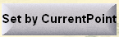 to set the current point as the end point. After setting successfully, the cutting head’s current point’s coordinate will be the same with the machine coordinate. Click to save.

3.7 Set Speed
Return to Main Menu. Press → to set speed.
3.10

- G00 Max Speed: 3000mm/min.
- Cutting Speed: Set the cutting speed you want.
- Z Axis Speed: 800mm/min
- Dynamic Adjust Z_Speed: 300mm/min. This is Z-axis speed during cutting. If you find the cutting head is too close to the material, press “page up” and “page down” to adjust the Z-Axis height.

If your material is uneven or you should always adjust Z-axis height during cutting, it is better to set the “Dynatic Adjust Z_Speed” to 100 mm/min.
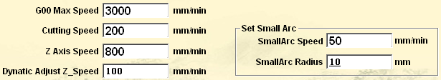
3.11
5 and 6. Set the small Arc speed and small Arc Radius.
When you cut small arc or small circle, the cutting speed should be at least half of the “Cutting Speed”.

3.8 Set holing time
3.12
Press → to set the holing time. Before cutting, the waterjet needs to pierce through first. Please modify this Item: to set the holing time, unit: seconds.

Chapter 4 Run the machine

4.1 Check
Once you have completed all the steps above and everything is positioned the way you want, you can finally ready to start.
Please check all the indicators of the machine after setting all the parameters well.
Low-Pressure Water Inlet is on or the water pump is on. The Water pressure gauge data >0.3Mpa
Intensifier Pump Power Supply is on and no alarm.
Start Air Supply and air pressure>0.25Mpa
Prepare enough abrasive and the auto abrasive feeder is turned on.
There is not any potential danger in the machine.

4.2 Automatic Cutting
Click 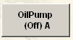to start Oil Pump, then wait for 5 seconds, then Click 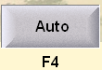→ 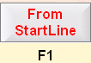→ to start cutting.

4.3 Stop the machine
Please Press if you want to stop cutting.

4.4 Continue cutting
If you want to continue cutting, please press 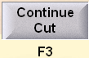→.

4.5 Start from any part

