CNC Water Cutting Machine Software Instructions
Simplified Version

- The software supports .DXF .NC .CNC files.
- Add zero point.
- Use AutoCAD to draw the cutting design and save as designated file.
- To save:
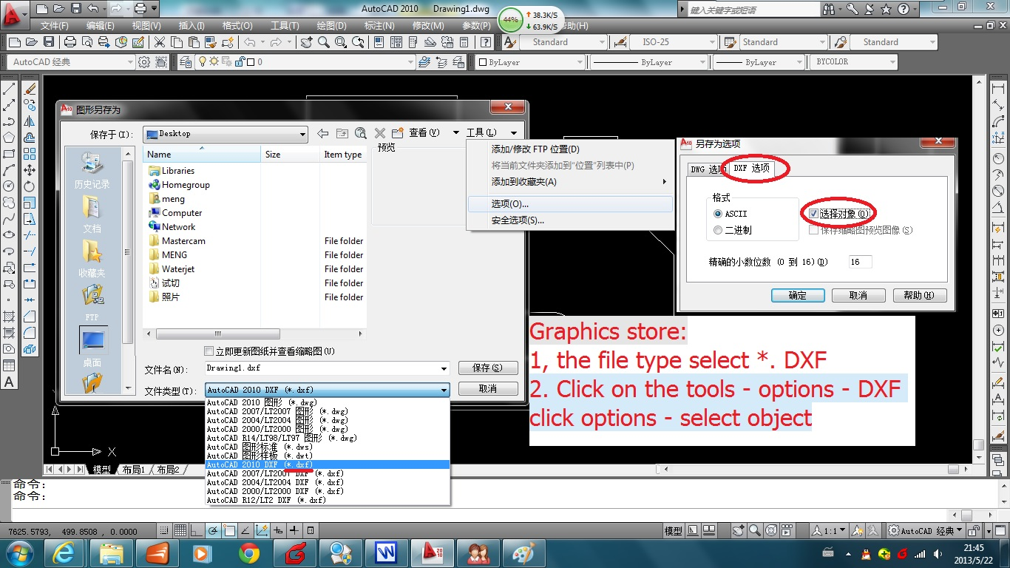
DXF

click
Select object
DXF Option
Options
Tools
- File Save As .dxf Tools (top right) Options DXF Options Select Object Save
- Return to graph, cick on the Zero Point, outline(choose) the designated image, ENTER
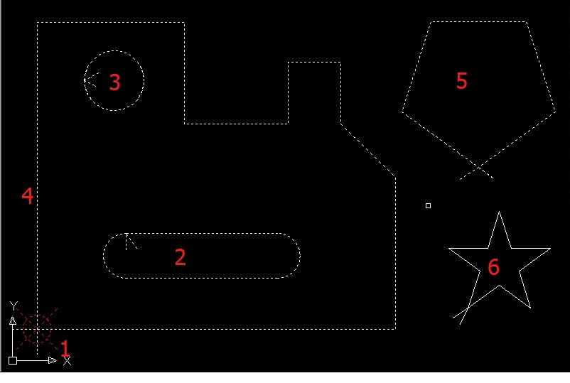

Using WaterJet CNC Software

- Double click from Desktop to enter the software
- Turn on Green Drive Button
- This is the screen that will open. Note: the values may differ
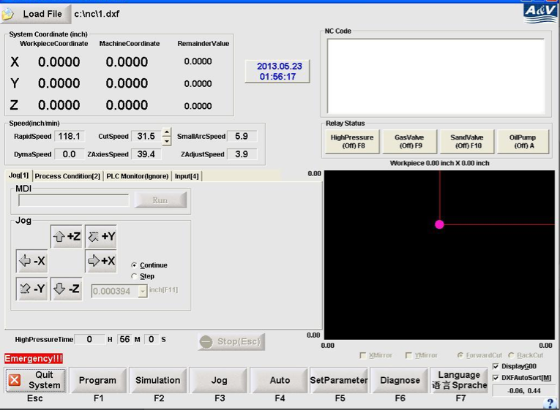
- To upload a file, click on the Load File button at top left corner.
- Make sure the File Type is .dxf or .nc, or you may not be able to find the file. Double click to upload
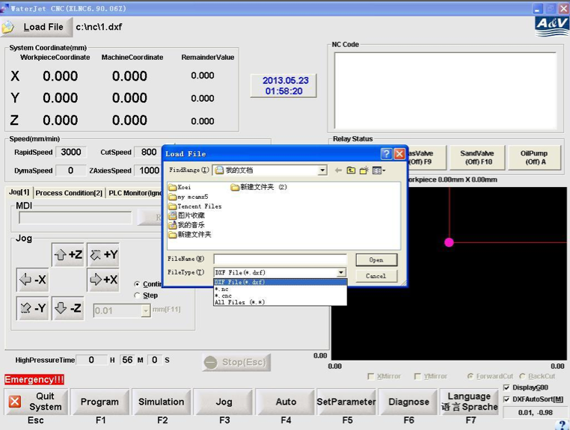
- After selecting the file. The design should appear on the lower right screen. Above that in the NC Code box, lists the coding of the design.
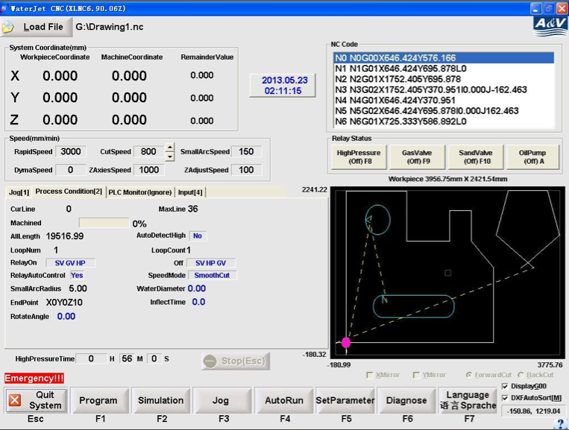
- The Menu is at the bottom of the screen:
- Program: Will display the entire NC Code of the design. Note: the program only operates G00, G01, G03, & G04.
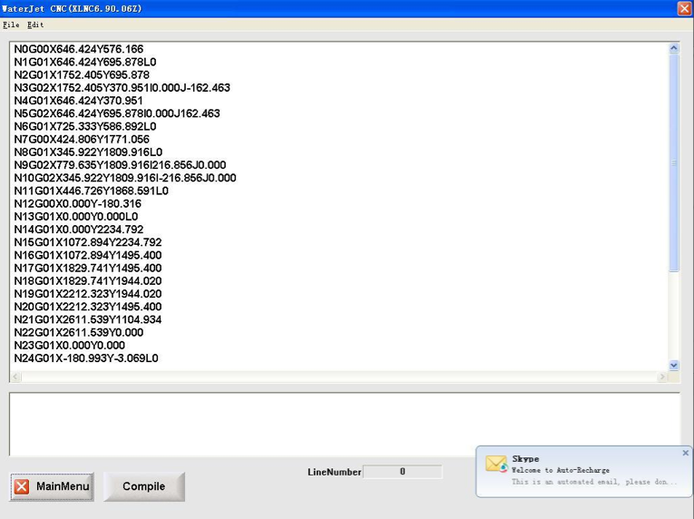
- Simulation: Will allow you to digitally run the design without the cutting platform. The speed can be changed with the dial on the right side of the screen.
  - From Start Line [F1]: Cut from the beginning
  - From Any Line [F2]: Cut from a chosen line by entering the line number. To find line number, right click on the graph and choose Display Line Number.
  - Display G00: Displays the rapid lines as dotted lines.
  - DXFAutoSort [M]: Automatically connects all the lines to create a smoother run.
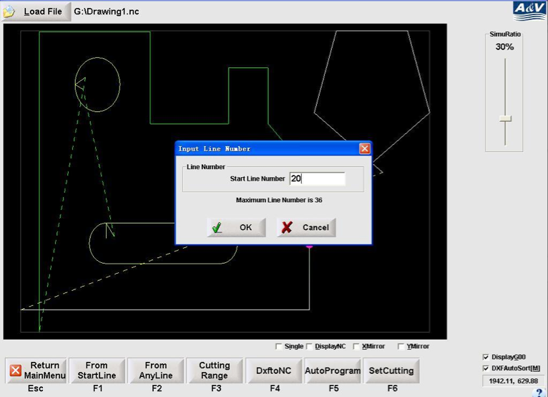

  - Cutting Range[F3]: Lists the properties of the design
    - Max & Min of X and Y
    - All Cut Length: Total distance
    - All Line: Total lines
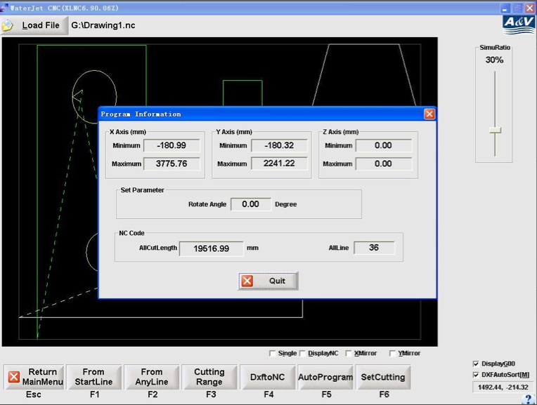
  - DxftoNC: Serves the same function as Load File.
  - Auto Program[F5]: Generates coding for Rectangles and Circles
    - Enter the measurements and click Generate Code. It will allow you to save the code to your computer as a .nc file.
    - To use, you will have to go to Load File and upload the code to the program.
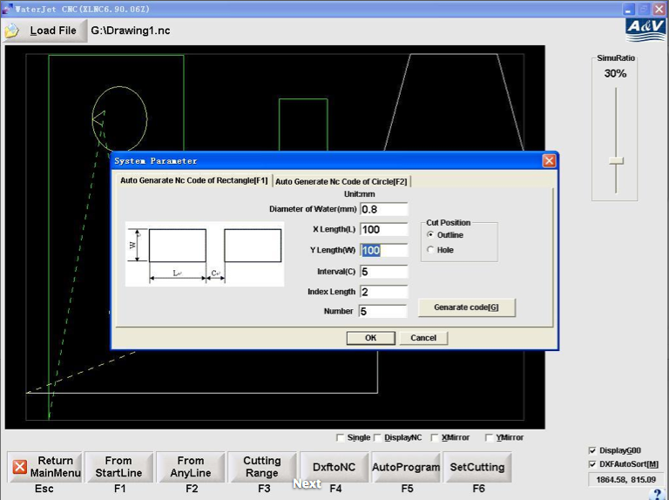

  - Set Cutting[F6]:
    - Option of Rotate: The degree that the design is cut at.
    - Safe High: The Rapid Height. How high the head rises to move to a new spot while cutting.
    - Contour Type: to change position of the Lead In Line. Should be kept on Outer for most designs.
    - Cut Direction: The direction that the head moves in.
    - Entrance Line and Outlet Line: The lead in line and lead out line.
      - Auto-add: the software will automatically add the lines.
      - Single Line: the lead in line and lead out line will be combined.
      - Length: The length of the lines.
    - Compen of Water Diameter: Compensation of the cut.
      - No Compen: will cut on the original line.
      - Left Compen & Right Compen: Will not cut on the original line in order to produce the correct size. The choice will depend on the design. Note: dark blue is always the original design.
      - Water Diameter: How much to compensate. Will depend on the size of the nozzle.
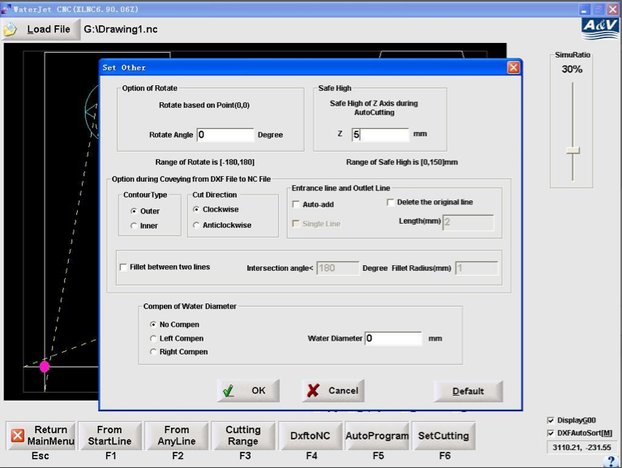
- Jog:
  - Set Current Point [F1]: After choosing the desired area to cut on a material, move the head to the outermost point of that area. Lower the head[Z] to about 3 mm above the material. Enter Set Current Point and select the corresponding point of which the head is located, zero the Z. This will allow the machine to determine the domain of the image.
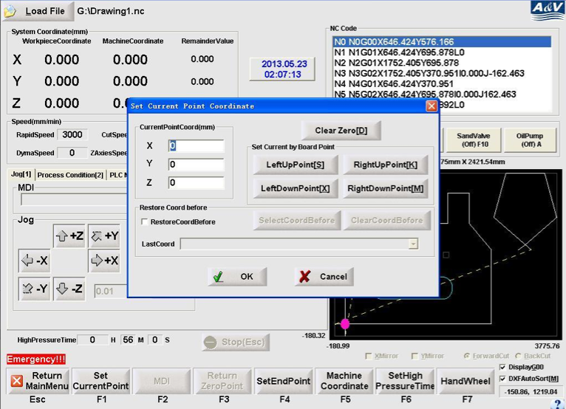
  - Set End Point: To determine where the head goes when finished cutting. By checking No XY Endpoint, the head will lift up at the finishing point. Note: No XY Endpoint is suggested to ensure the safety of the nozzle.
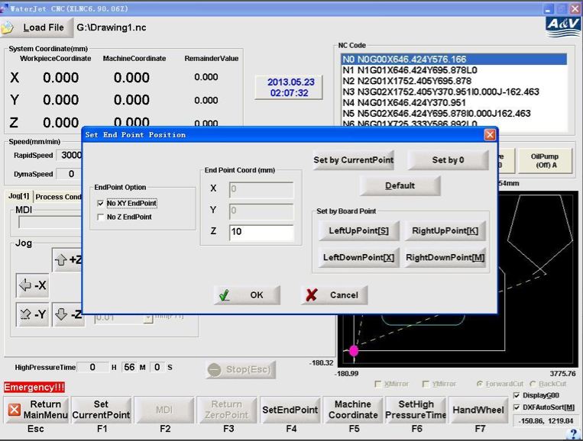

- Auto Run: To start cutting. Functions the same way as Simulation (See #8).
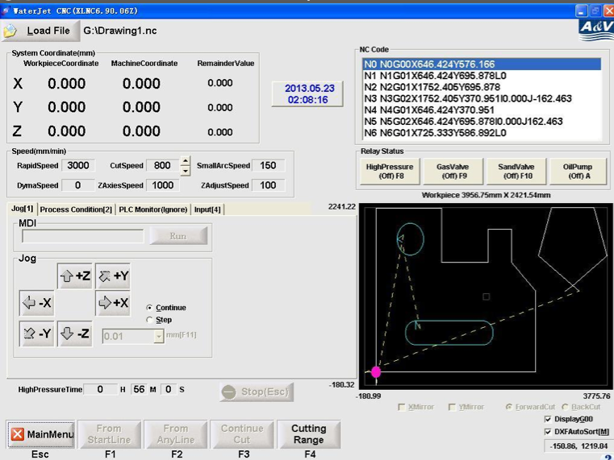
- Set Parameter[F6]:
  - Set Speed [F1]
    - G00 Max Speed: Quickly change the Rapid Speed
    - Cutting Speed: Quickly change the Cutting Speed
      - Note: the range of the speed is shown in red.
    - Set Small Arc Speed & Set Small Arc Radius: When cutting thick material, it is suggested to cut the small circles and arcs at a slower speed. When the radius of an arc reaches the determined measurement, it will slow down to that speed. Set Arc Radius to 0 to disable.
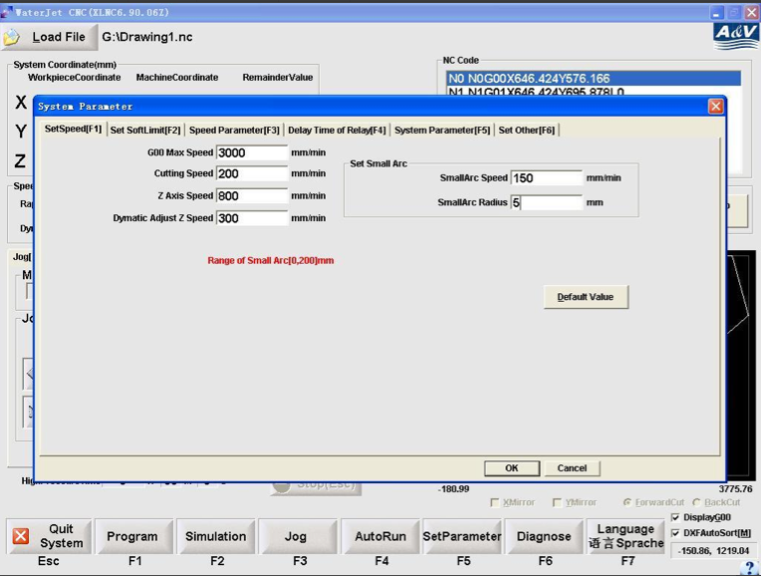
  - Set Soft Limit [F2]: Do not need to be changed
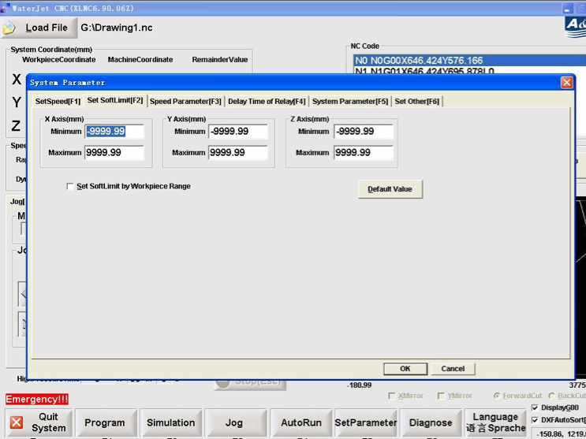

  - Set Parameter [F3]: Do not need to be change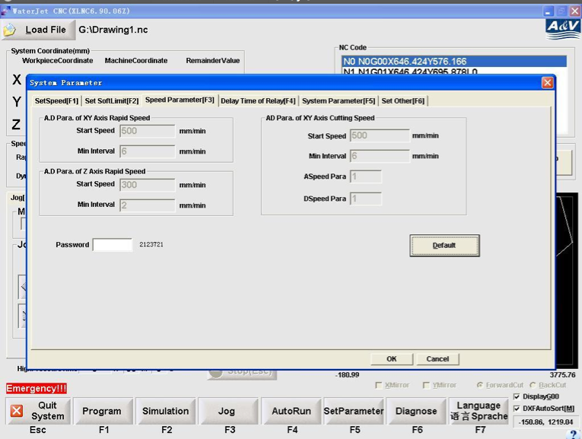
  - Delay Time of Relay [F4]:
    - Time After On: How long the initial blow is, in seconds.
    - Time After Off: How long the water flows after the final cut, in seconds.
    - Replay By Auto Control[C] (checked): AutoRun will automatically turn on Gas Valve, Pressure Valve, and Sand Valve. By unchecking, you can perform a dry run.
    - All others do not need to be changed

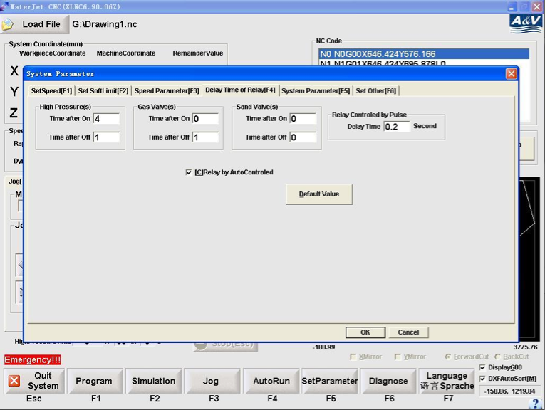

    - System Parameter[F5]: Should remain the same. If the system resets, set Control Mode of Relay to 4. Change by entering the numbers listed after the password box.
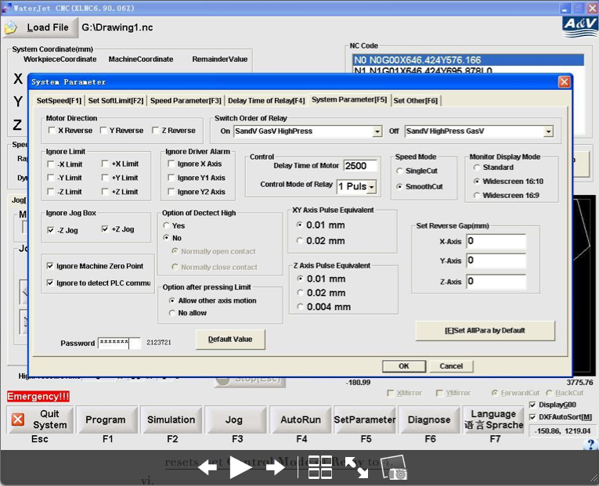
    - Set Other[F6]: Should remain the same.
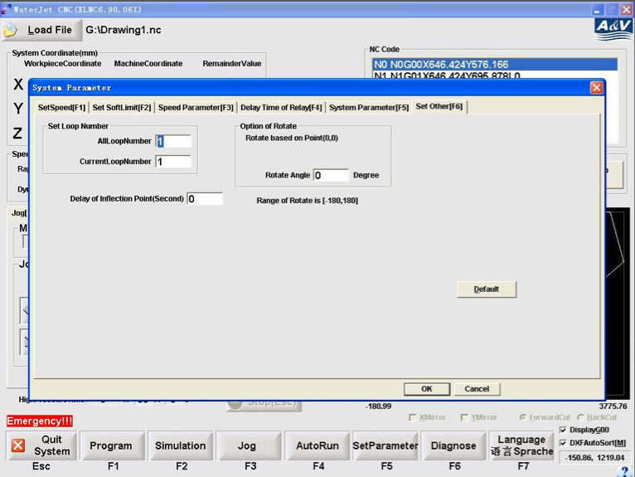
- Diagnose [F6]: Can be ignored.
- Language [F7]: To change the language and the measurement system.
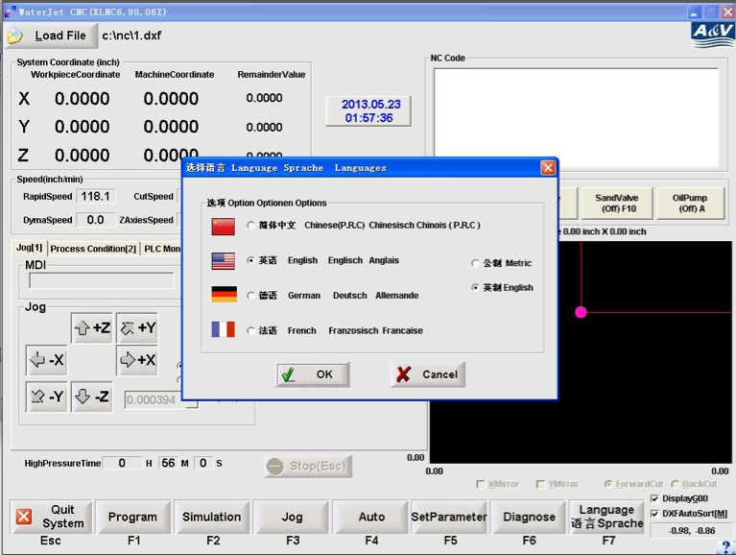

Quick Guide to Machine Operation

- Turn on the main switch (black on high pressure pump), and turn on White Button.
  - This will turn on the Cutting Platform and Sand Tank
- Turn on both water sources
  - Cutting Water pressure should be in between 40psi~80psi
  - The machine will shut off by itself if the water pressure falls bellow 30psi.
- Turn on air
  - Sand Tank air pressure should be in between 30psi~40psi.
  - Cutting Platform air pressure should be around 0.5 MPA.
- Make sure there is enough sand in the Sand Tank
- Clear and fix any alarms on the High Pressure Pump. Shown on the screen next to the main switch.
- The hydraulic oil should remain below 45 °C.
- Open Software, turn on Green Driver Button
- Load File
- Move head desired cutting position. Y-axis: 2 & 8; X-axis: 4 & 6; Z-axis: pg up & pg down
- Set desired speed and time of initial blow (set parameter)
- Jog Set Current PointZero the Z
- Turn on Oil Pump, wait until warmed up
- AutoRunFrom Start Line/From Any Line
- ESC to pause/stop

