A&V Waterjet Software
Parameter Settings for Different Materials

- Click the A&V Waterjet Cutting Software on the desktop.

- The mainmenu of the software is like shown below:
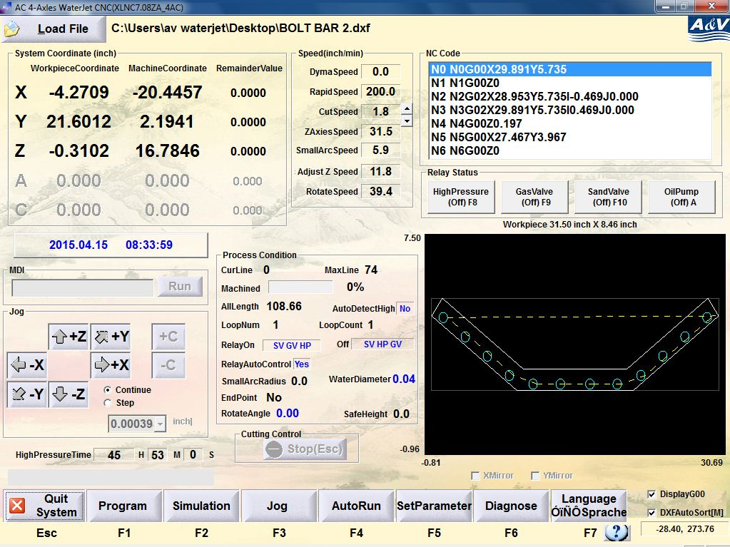

- Click ‘Load file’ to load the DXF file you need to use.

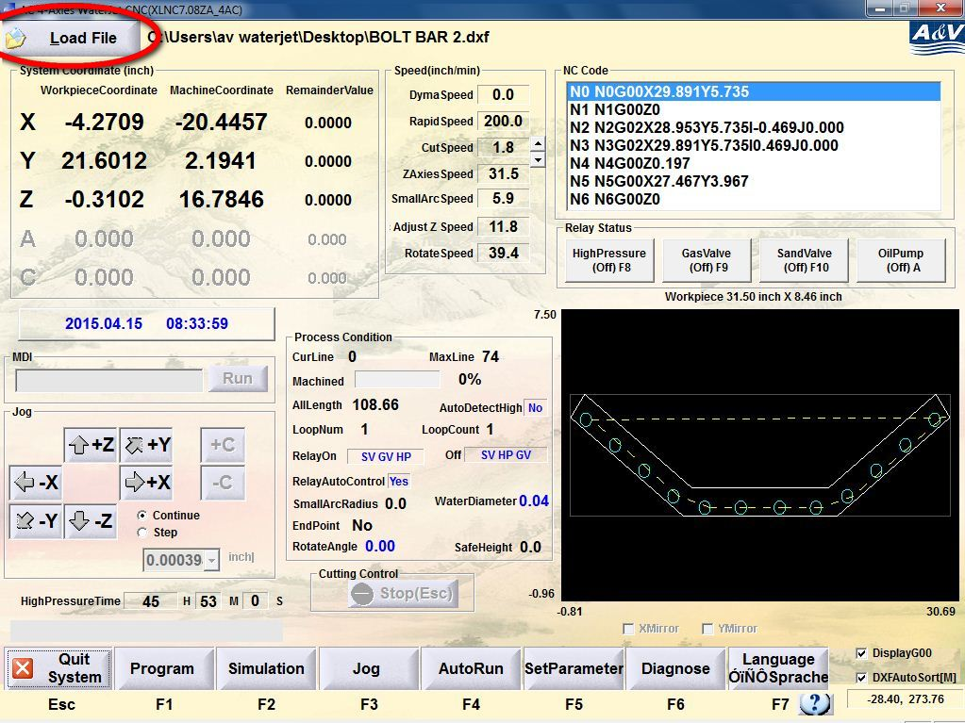

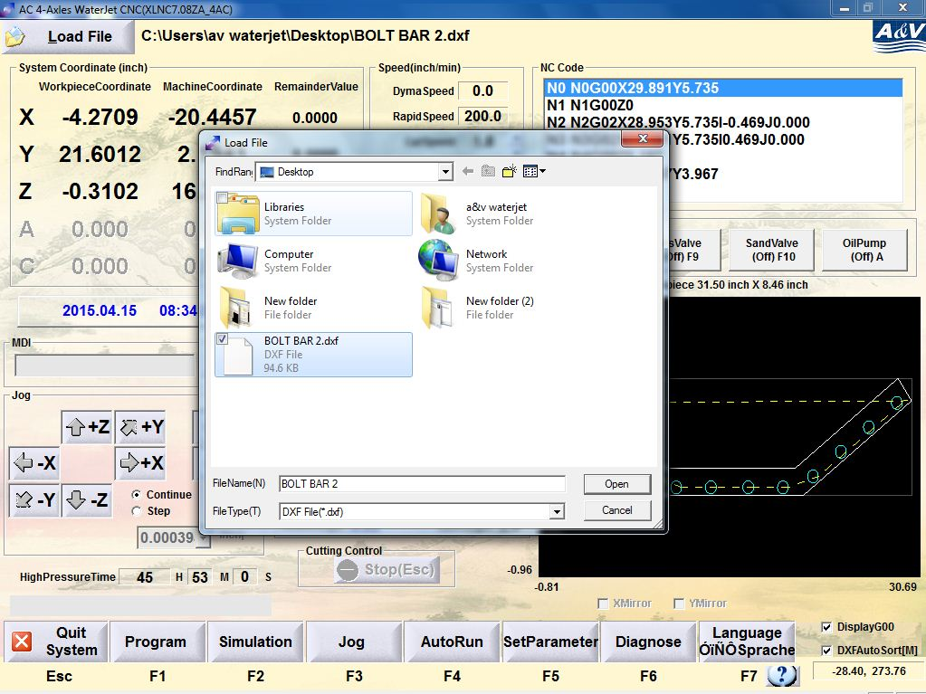

- After double checking the drawing, click ‘SetParameter’ or press F5 to enter the parameter setting menu.

- In the SetSpeed tag, the picture will be shown.
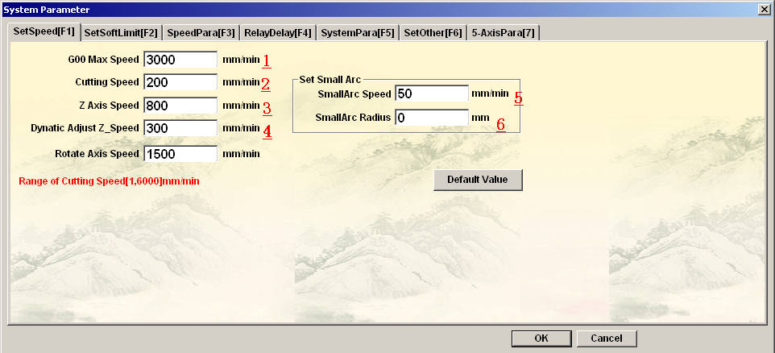
- G00 Max speed:
The cutting head will move in such a speed when:
- using on the keyboard
- The machine is executing G00 code in auto cutting mode
**** During run-in period, generally we will set the value as 3000MM/MIN****
- Cutting speed:

Please refer to the appendix 1 for certain material.

- Z axis Speed:
The cutting head will raise or drop in such a speed when are used on the keyboard.

**** During run-in period, generally we will set the value as 600-1000MM/MIN****

- Dynamic Adjust Z_Speed:

When executing cutting code such as G01, G02, G03, for best cutting quality, we will set the distance from the cutting head to the part that we are cutting as 3MM. If the surface of the part is not plain enough, there may be damage to the cutting head.

**** Generally we will set the value as 100MM/MIN****

- SmallArc Speed & 6) SmallArc Radius

When cutting small circles or arcs with high hardness or thickness (more than 10mm) material, for best cutting quality, you can decrease the arc cutting speed by changing the parameters here.

For example as shown in the parameter setting below, we define the SmallArc Speed as 50mm/min and SmallARC Radius as 10mm. When the system is cutting any circle or arcs with the radius less than 10mm, the cutting head will move in the speed of 50mm/min to keep the cutting surface smooth. The other lines or arcs will keep the general cutting speed.

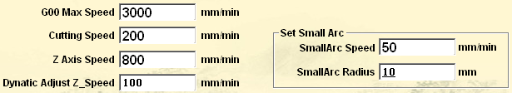

- Relay Delay

Before cutting through the entrance line, the cutting head needs to pierce first.

- In main menu, click ‘SetParameter’ or press F5 to enter the parameter setting menu.

- In the ‘RelayDelay’ tag (or press F4), change the delay time.
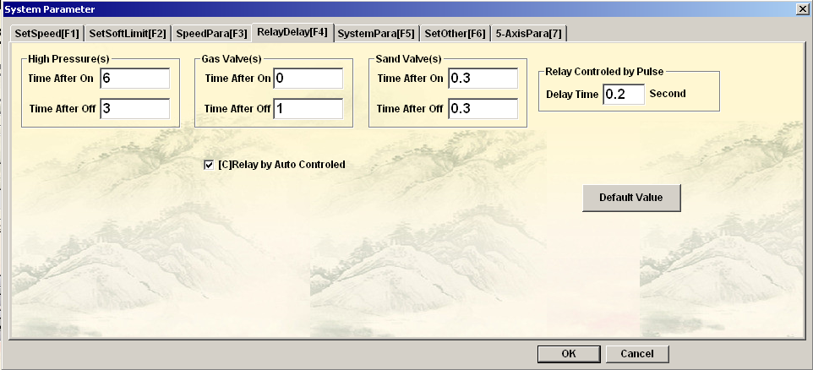
****For materials with different thickness, also see appendix for parameters****

Appendix
Parameter settings for common materials

Material | Pressure (MPa) | Thickness (mm) | Cutting Speed(mm/min) | Delay
 |  |  |  | HP on(s) | HP off(s) | Sand Valve on (s)
Iron/ Steel | 340 | 3 | 630 | 2 | 0 | 0
Iron/ Steel | 340 | 5 | 349 | 2 | 0 | 0
Iron/ Steel | 340 | 8 | 208 | 3 | 0 | 0
Iron/ Steel | 340 | 10 | 157 | 3 | 0 | 0
Iron/ Steel | 340 | 12 | 127 | 4 | 0 | 0
Iron/ Steel | 340 | 15 | 99 | 4 | 0 | 0
Iron/ Steel | 340 | 20 | 71 | 6 | 0 | 0
Iron/ Steel | 340 | 25 | 55 | 7 | 0 | 0
Iron/ Steel | 340 | 30 | 44 | 8 | 0 | 0
Iron/ Steel | 340 | 35 | 37 | 9 | 0 | 0
Iron/ Steel | 340 | 40 | 32 | 10 | 0 | 0
Iron/ Steel | 340 | 45 | 28 | 12 | 0 | 0
Iron/ Steel | 340 | 50 | 25 | 12 | 0 | 0

Material | Pressure (MPa) | Thickness (mm) | Cutting Speed(mm/min) | Delay
 |  |  |  | HP on(s) | HP off(s) | Sand Valve on (s)
Aluminum | 340 | 5 | 1000 | 2 | 0 | 0
Aluminum | 340 | 8 | 624 | 3 | 0 | 0
Aluminum | 340 | 10 | 483 | 4 | 0 | 0
Aluminum | 340 | 15 | 303 | 4 | 0 | 0
Aluminum | 340 | 20 | 210 | 5 | 0 | 0
Aluminum | 340 | 25 | 168 | 5 | 0 | 0
Aluminum | 340 | 30 | 136 | 6 | 0 | 0
Aluminum | 340 | 35 | 114 | 6 | 0 | 0
Aluminum | 340 | 40 | 98 | 7 | 0 | 0
Aluminum | 340 | 45 | 86 | 7 | 0 | 0
Aluminum | 340 | 50 | 76 | 8 | 0 | 0

****For the materials below, change the on/off sequence for the relay by clicking ‘SetParameter’ (F5) on main menu then ‘SystemPara’ (F5)
From 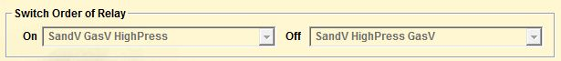
To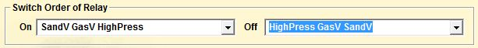

Material | Pressure (MPa) | Thickness (mm) | Cutting Speed(mm/min) | Delay
 |  |  |  | HP on(s) | HP off(s) | Sand Valve on (s)
Glass | 300 | 5 | 1000 | 2 | 2 | 0.3
Glass | 300 | 8 | 876 | 2 | 2 | 0.3
Glass | 300 | 10 | 600 | 2 | 2 | 0.3
Glass | 300 | 12 | 530 | 3 | 2 | 0.3
Glass | 300 | 15 | 425 | 4 | 2 | 0.3
Glass | 300 | 20 | 305 | 4 | 2 | 0.3
Glass | 300 | 25 | 230 | 5 | 2 | 0.3

Material | Pressure (MPa) | Thickness (mm) | Cutting Speed(mm/min) | Delay
 |  |  |  | HP on(s) | HP off(s) | Sand Valve on (s)
Marble | 320 | 8 | 1000 | 3 | 2 | 0.3
Marble | 320 | 10 | 800 | 3 | 2 | 0.3
Marble | 320 | 12 | 680 | 5 | 2 | 0.3
Marble | 320 | 15 | 533 | 5 | 2 | 0.3
Marble | 320 | 20 | 383 | 5 | 2 | 0.3
Marble | 320 | 25 | 296 | 6 | 2 | 0.3
Marble | 320 | 30 | 240 | 6 | 2 | 0.3

