A&V Waterjet Cutting Zero Point Setting Instruction

- Click the A&V Waterjet Cutting Software on the desktop.

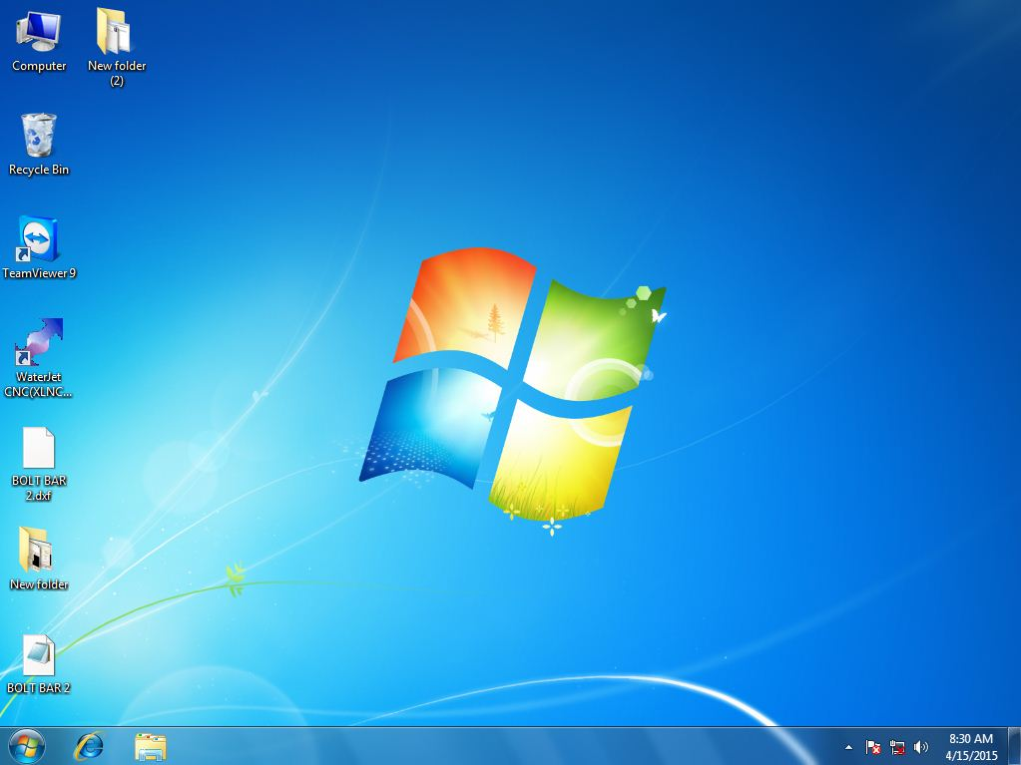

- The mainmenu of the software is like shown below:
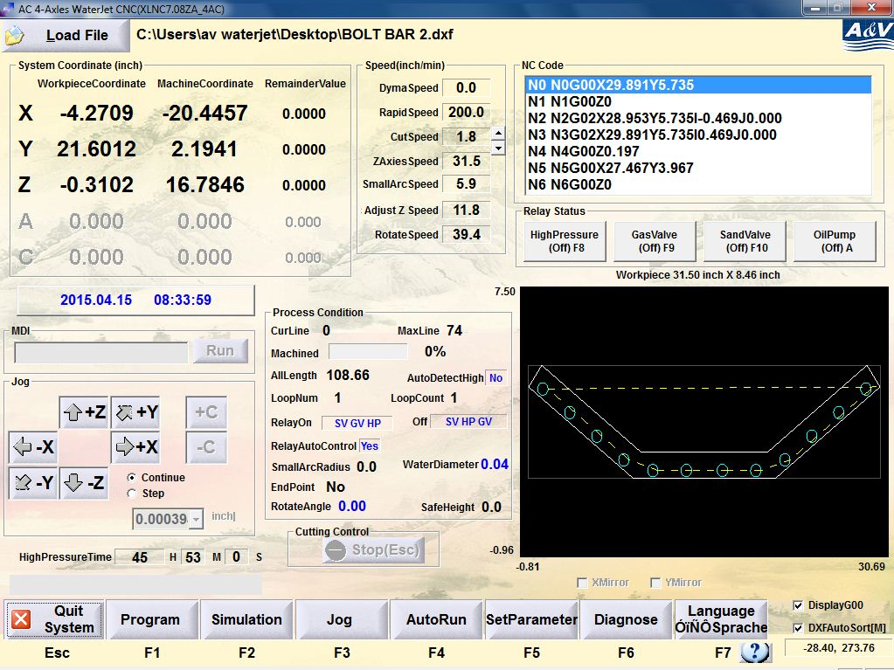

- Click ‘Load file’ to load the DXF file you need to use.

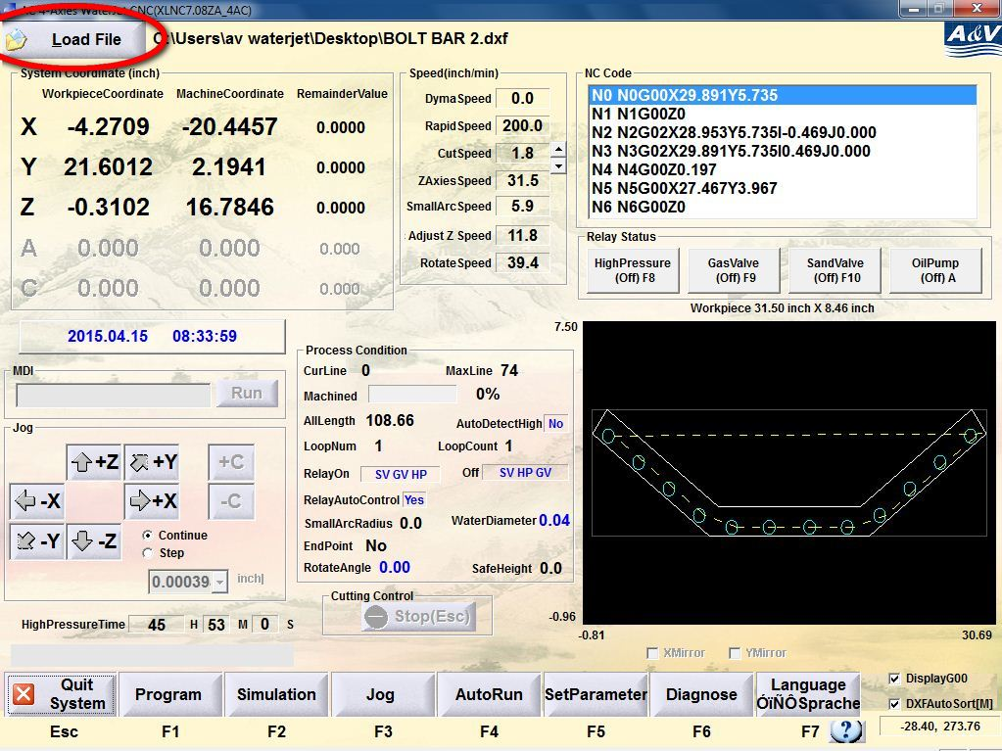

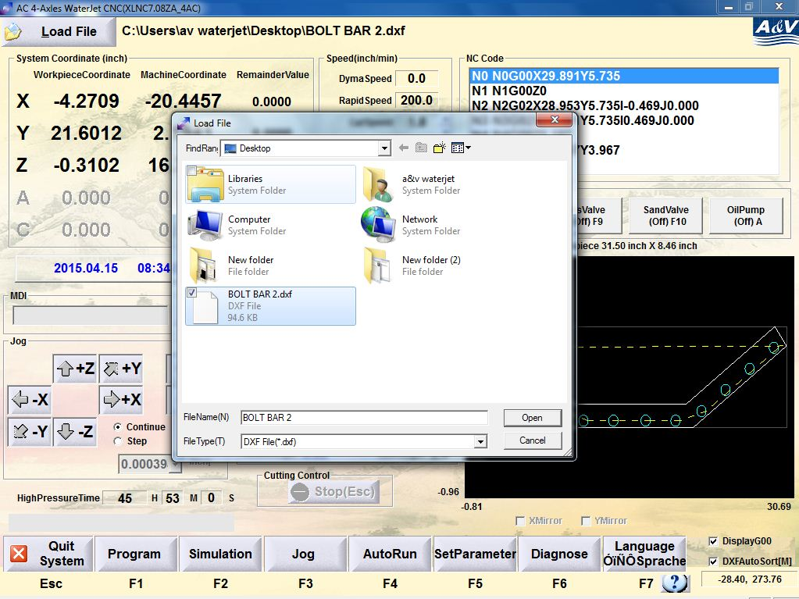
- The main menu should be shown like this:

- Use 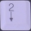 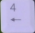 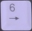 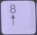 on the keyboard to adjust the location of the cutting head within the range. Stop at the cutting zero point that you need.

- Click ‘Jog’ or press F3 then choose ‘SetCurrentPoint’ or press F1 to enter the current point setting menu like shown below

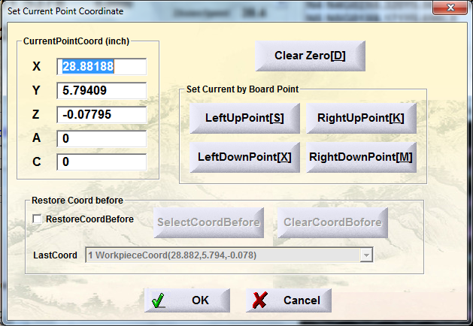
- Set the numbers in ‘X’, ‘Y’, ‘Z’ as 0 like shown below then click ‘OK’.

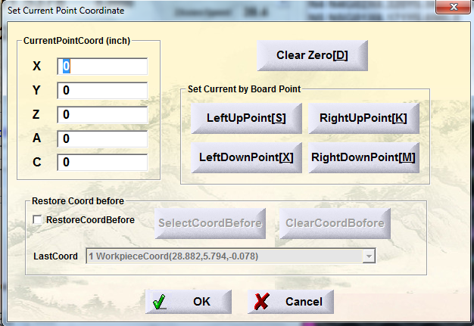

- In the main menu, notice that
- The ‘WorkspaceCoordinate’ for ’X’, ‘Y’, ‘Z’ have been changed to zeros.
- The starting point has been located in the certain place in the simulation figure.
