A&V Waterjet MDI Mode Instruction

Enter a single line NC code to process under the MDI mode. This function is the most suitable for manual simple localization and cutting.

- Click the A&V Waterjet Cutting Software on the desktop.

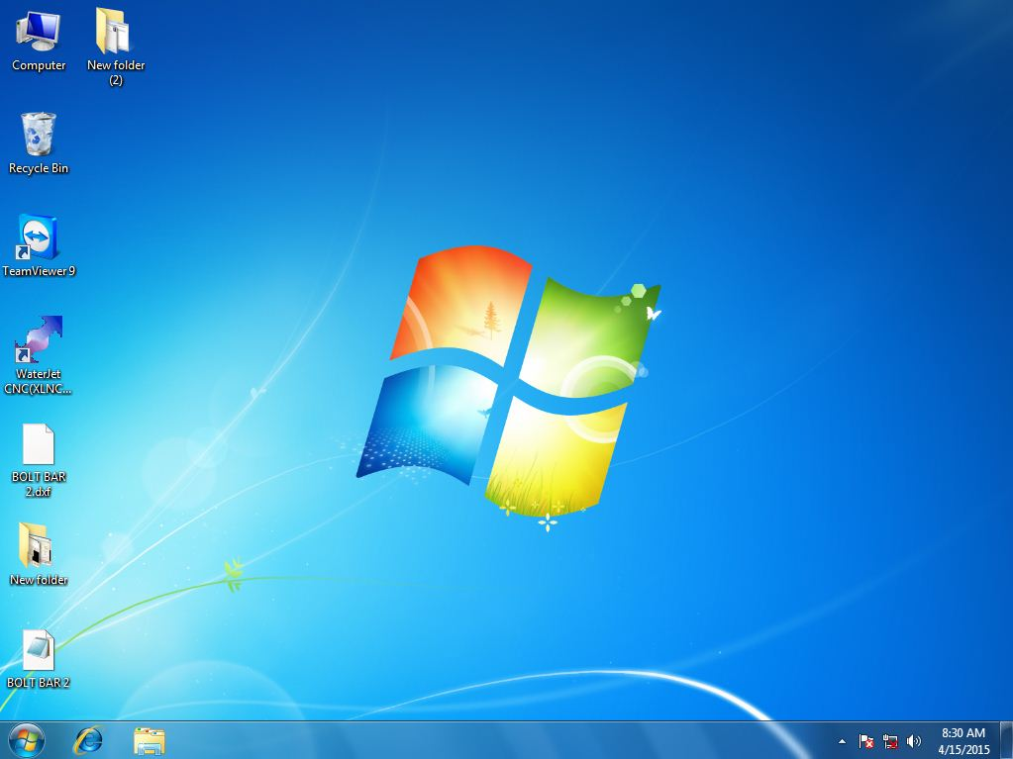

- The mainmenu of the software is like shown below:
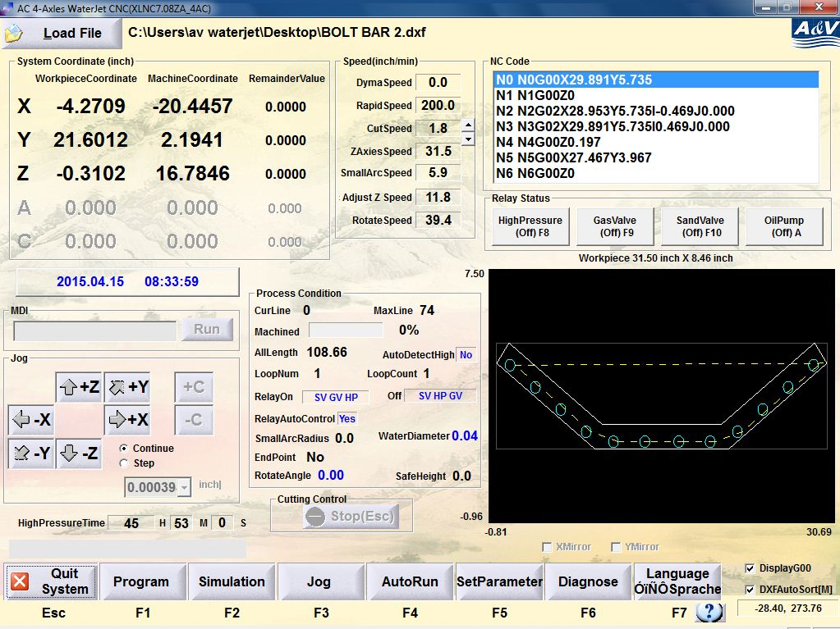

- Use 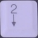 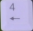 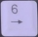 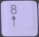 on the keyboard to adjust the location of the cutting head within the range. Stop at the cutting zero point that you need.

- Set cutting zero point as shown in the KM article ‘A&V Waterjet Cutting Zero Point Setting Instruction’.
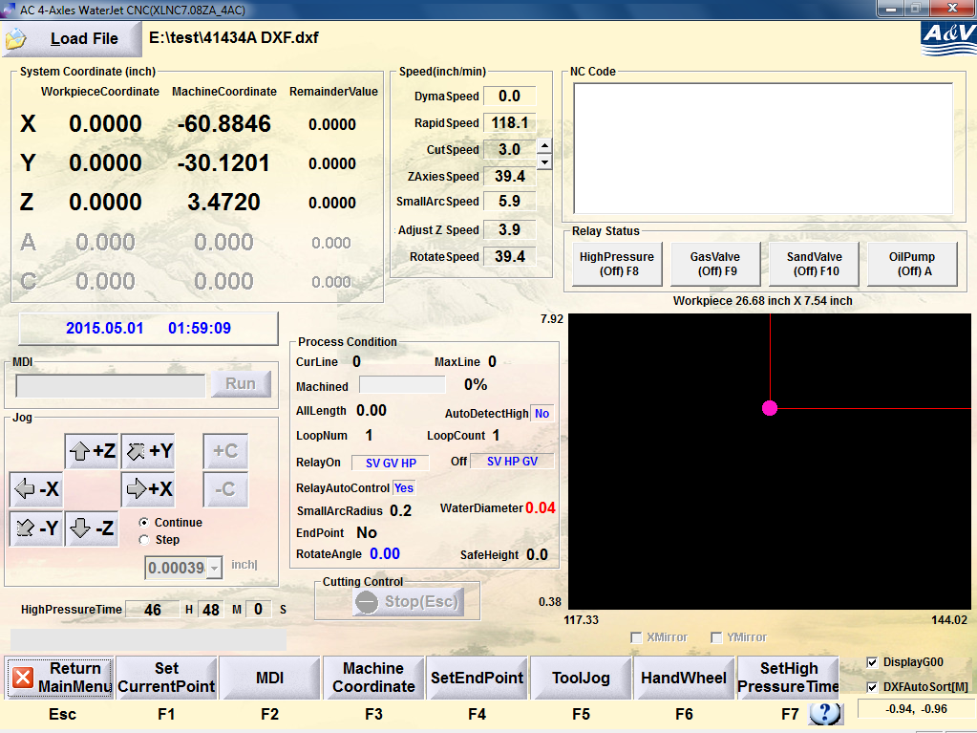

- Click ‘MDI’ or press F2. The ‘Run’ button under ‘MDI’ column will be highlighted.
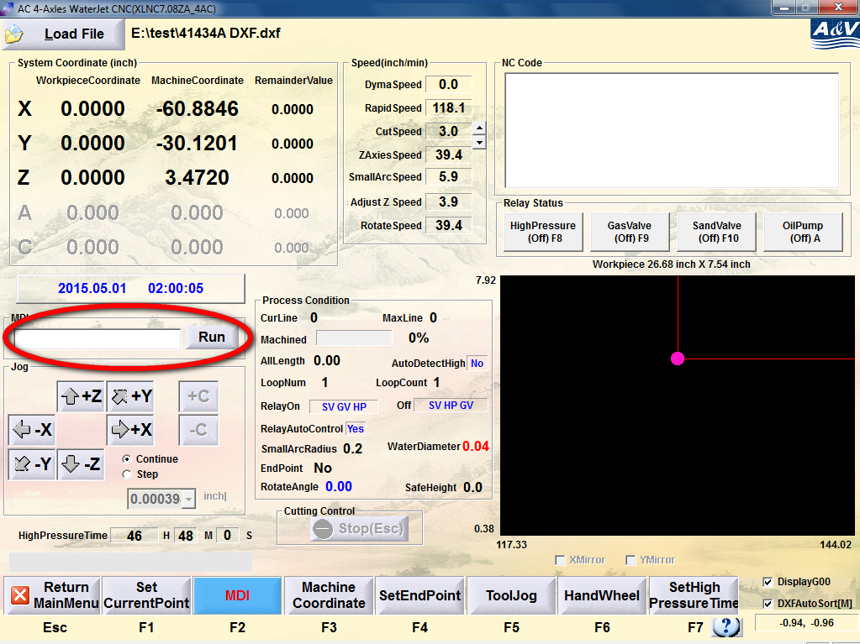
- Enter single line G- code into the command box

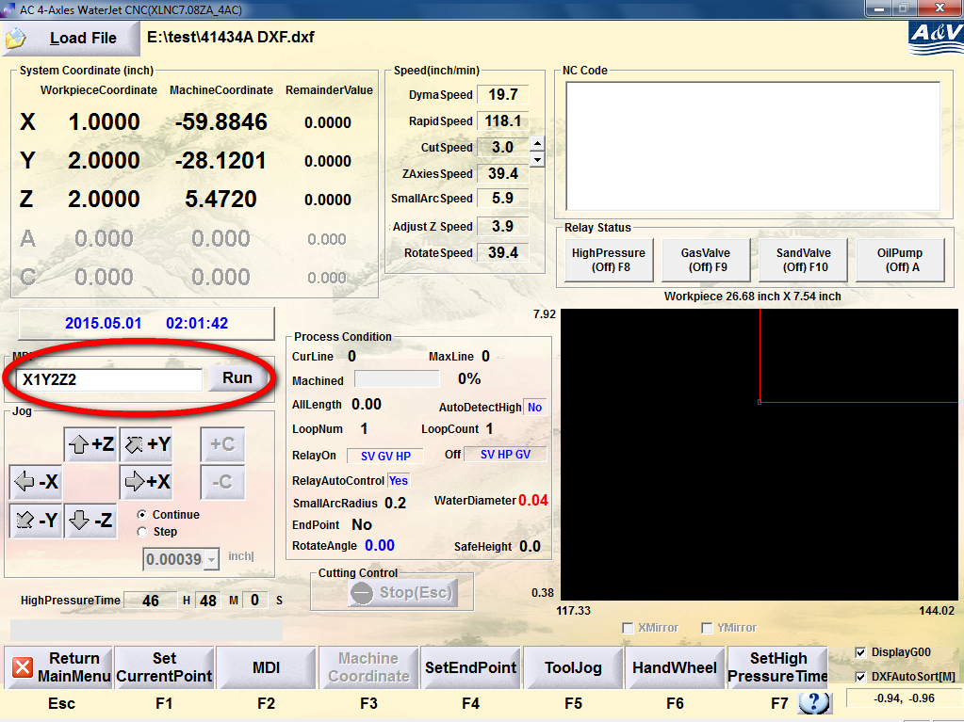

- To cut parts manually, click the buttons in the sequence of
‘OilPump’, ‘Gasvalve’, ‘HighPressure’, ‘SandValve’, and then click ‘Run’ button circled in red in the previous picture. The system will execute the G- code automatically.
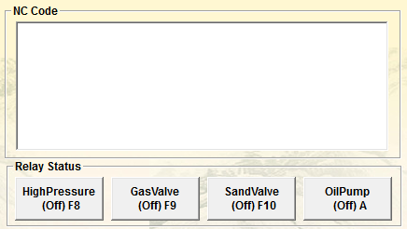
- After the execution of G- code, close all the valves in reverse sequence, e.g.
‘SandValve’, ‘HighPressure’, ‘Gasvalve’, ‘OilPump’.

