A&V Waterjet Garnet Feeding System User’s Manual

The garnet feeding system is like shown in the picture below.

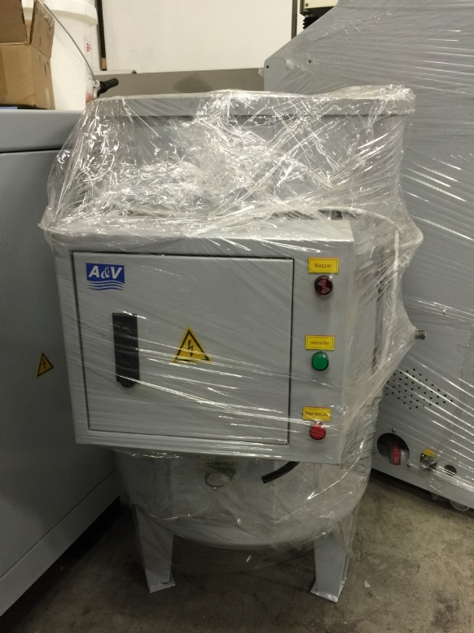 

1. Electric Box

The electric box is attched to the garnet hopper like shown below.

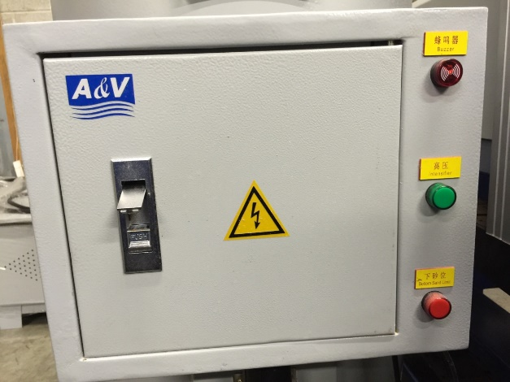 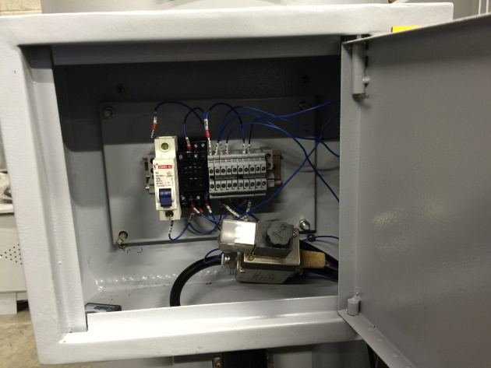

1. How To Put Garnet In

1. Turn off the power of the garnet feeding system using the switch in the electric box like shown below.

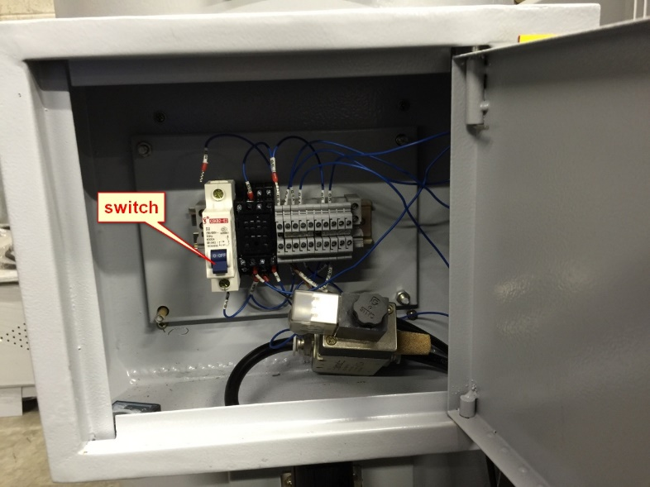

1. Lift the cover of the hopper. Once the power is cutting off, the brown ball (A in the picture below) inside the hopper will drop down. Put 4 or 5 bags of garnet through the hole.

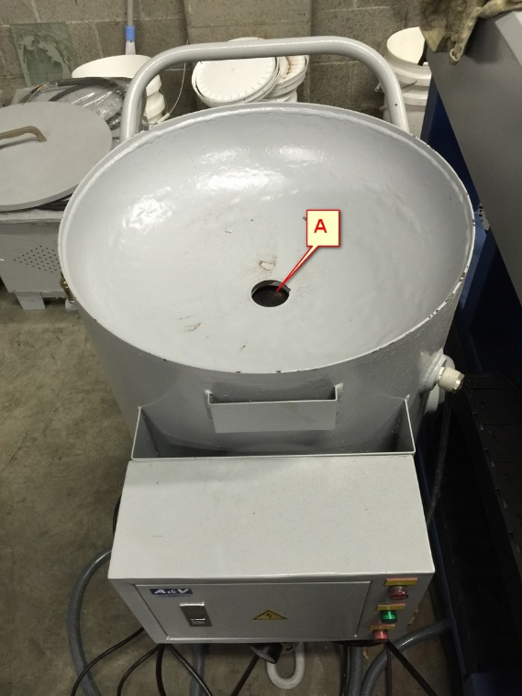

1. Working Status

In working status, ball A inside the hopper should be pushed up by air so there is no gap between the ball and the hopper. Also the green light on the electric box is lit up.

1. Common errors

|  |  |  |
| --- | --- | --- |
| *Symptom* | *Possible causes* | *Solution* |
| garnet leaking out from the mini hoppers which attached besides the X axis | Garnet clogged in the garnet hopper | Open the garnet hopper, remove the wet garnet. Clean the hopper and put new garnet in (click here to see) |
| Garnet in the garnet hopper is wet |
| Air pressure is too high | Manually reduce the air pressure (click here to see) |
| In short of garnet (the red light lit up and the buzzer beeped on electrical box) | Put more garnet in |
| Water back up to the mini hopper | Block up in the mini hopper | Clean the mini hopper and dry it (click here to see) |

1. How to clean
2. Garnet hopper
3. Place it down on ground like shown below

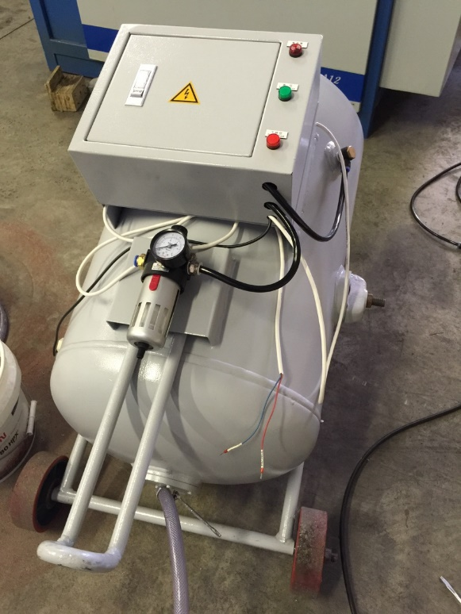

1. Loose the screw on the pipe, then remove the pipe from the garnet hopper

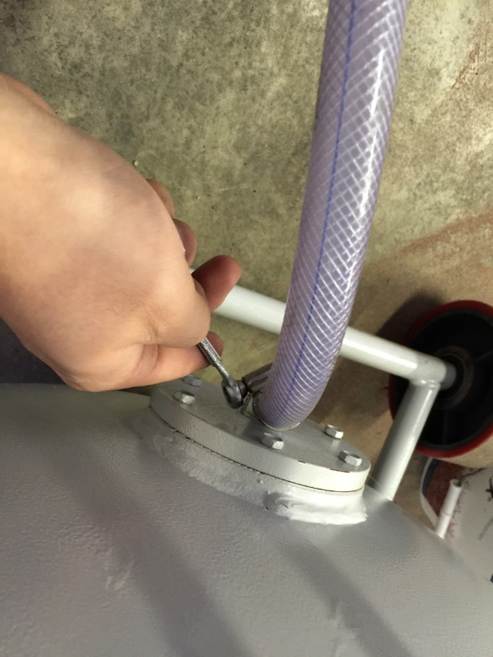

1. Remove the 6 screws attached on the bottom cover of garnet hopper.

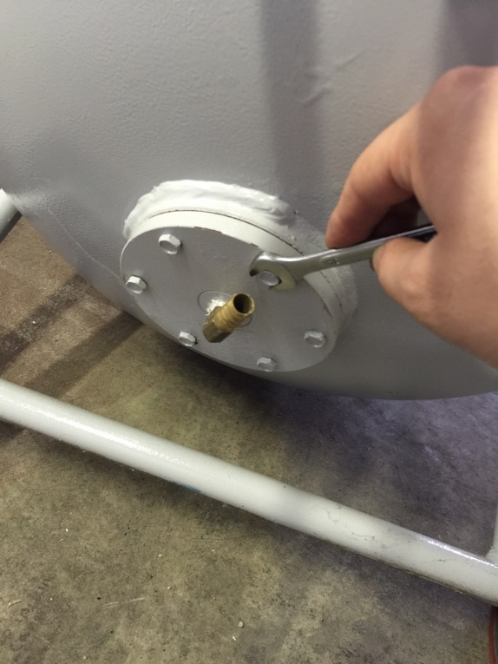

1. Remove the bottom cover

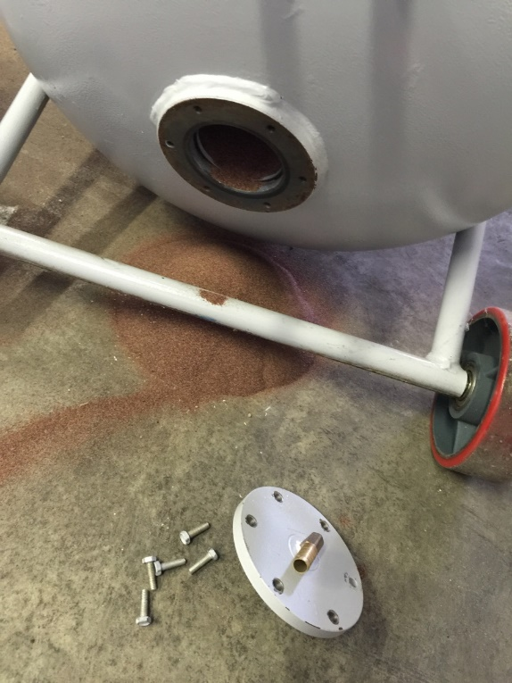

1. Remove all garnet from the hopper. Blow air or use dry cloth to clean the inside.
2. Screw the cover back. Make sure there is no garnet left between the bottom cover and the hopper. Otherwise there will be air leaking when use it.

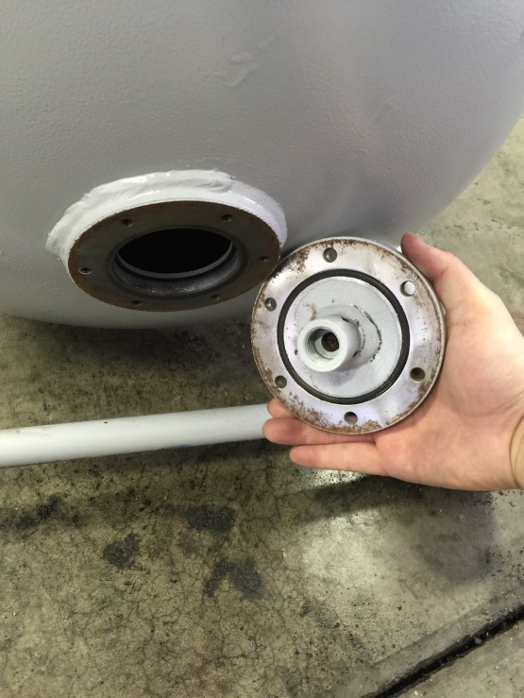

1. Put the hopper back to the right place and it will be ready to use.
2. Mini hopper
3. If the garnet in the mini hopper is clogged, disconnect the pipe to the z- axis.

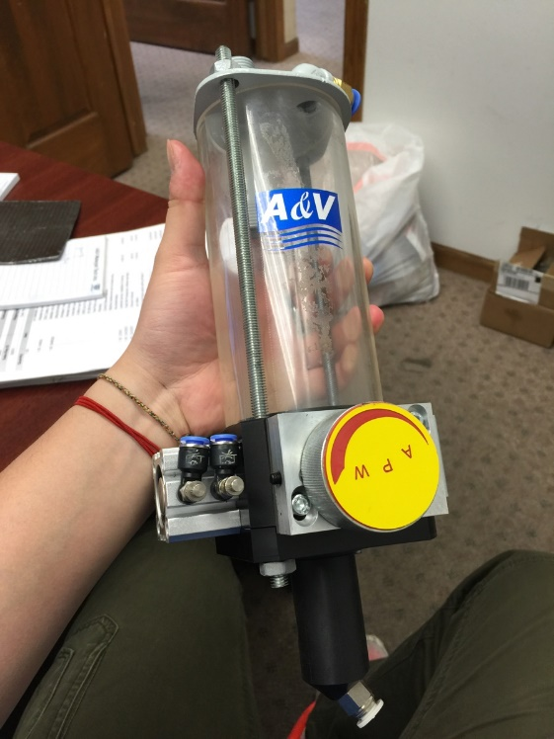

1. Blow air into the hole on the bottom of the mini hopper until drought.

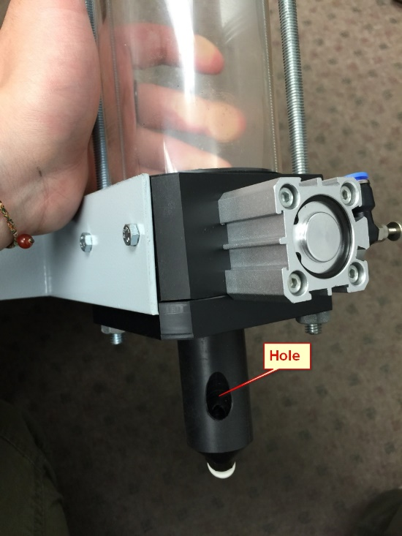

1. Put the mini hopper back to the machine and it will be ready to use.
2. How to manually adjust the air pressure

For the knob circled in the picture, twist it to a proper value (usually 2 or 3 psi)

